MECH 303

Machine Design

Project 3: Computational Investigation on a Novel Bracket Design

**Name:** Hakancan Öztürk

**Submission Date:** 25 January 2023

# Objective

The proposed design of a nut and bolt arrangement in a bridge structure aims to increase the load-bearing capability. In order to assure the reliability of the proposed design, it is necessary to examine its safety for applied loads through Finite Element Method (FEM) analysis. The FEM analysis will focus on the effect of bolt preadjustment and external force on the structure's stability and deformations.

The tasks for this FEM analysis are as follows:

**Part 1:** Apply a bolt preadjustment of 0.1 mm to all four bolts and compute the maximum and the average stress observed in all parts.

**Part 2:** Remove the bolt pretension from the bolts and apply the external force to the bracket (with a magnitude of 10 kN). Report the maximum and the average stress observed in all parts, maximum stress, nominal stress, and stress concentration factor for the hole of the bracket and compare it with Figure 4.40a found in the course textbook.

**Part 3:** Apply a bolt preadjustment of 0.05 mm to all four bolts and increase the external force applied to the pin from 0 N to 200 kN. Report the contact status of the plates and the bracket, estimate the force required to separate these parts from each other, and compute the working load for the bolts under these scenarios.

**Bonus:** Solve the same problem discussed in Part 1 and Part 2 but use symmetry boundary conditions and compare the results with the full model.

# Methodology

For this project, we used ANSYS static structural due to the nature of the problem. And the steps of FEM Static Structural Analysis are as follows:

Geometry Creation: The first step is to create a 3D model of the structure based on the provided technical drawings and specifications. This step involves the creation of the geometry of the structure on SpaceClaim within ANSYS, including all its components and parts, such as plates, bolts, and brackets. The material was selected as Structural Steel as it is defined within ANSYS.

|  |  |  |
| --- | --- | --- |
| Figure 1. The CAD models of the subsystems of the geometry, a) bracket, b) one of the plates, c) bolt and nut | | |

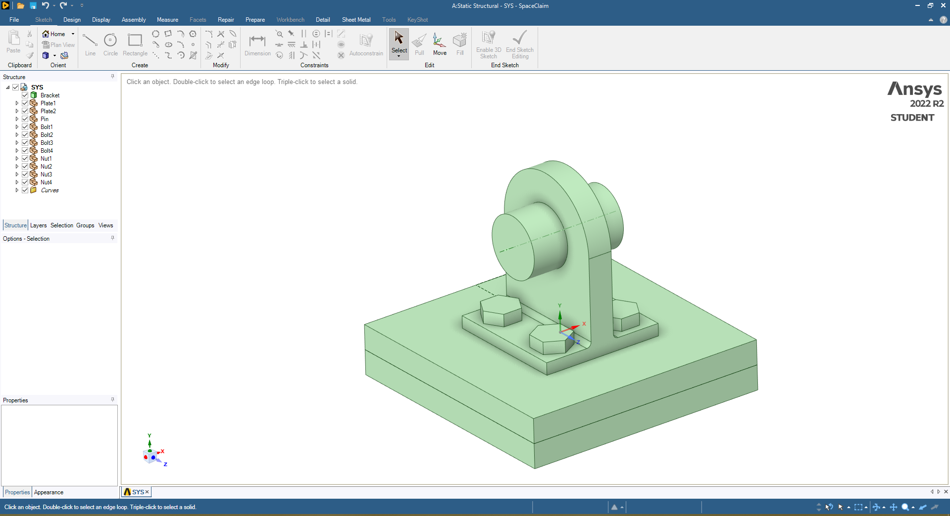

Figure 2. The CAD models of the problem geometry, with the proper naming

**Meshing:** The second step is to divide the structure into small finite elements using a meshing technique. This step is crucial for the accuracy of the analysis, and it is essential to choose an appropriate meshing technique and element size for the specific structure and problem.

The plates were meshed using the body sizing tool with a maximum element size of 3 mm.

The pin was meshed using the edge sizing tool with the number of divisions set to 30, due to its axisymmetrical shape.

The bracket plays an important role in this problem, therefore the body sizing was set to be a maximum element size of 2.5 mm. And inflation was introduced to the contact region with the pin.

The bolts were meshed using the body sizing tool with a maximum element size of 2.5 mm. The meshing was sufficiently fine, yet could be improved via the usage of the full version of ANSYS.

The nuts were also meshed using the body sizing tool with a maximum element size of 2 mm, due to their relatively small size.

Finally, due to the critical loading of the contact region of the bracket with the pin, the boundary face was also meshed, so that it will be easier to analyze the stress concentration region.

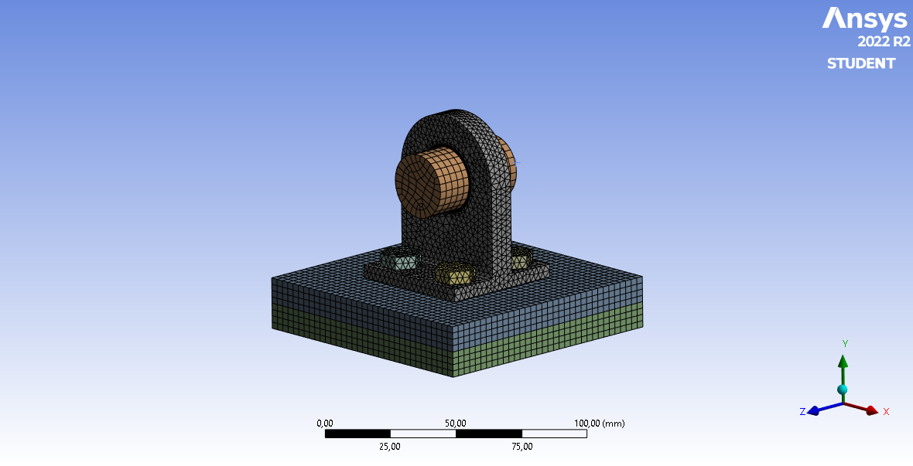

Figure 3. The final mesh of the problem geometry, in total, consists of 50k elements

**Boundary conditions and loads application:** The final step of the pre-processing is to define the boundary conditions and loads that will be applied to the structure. This step includes defining the fixed and free nodes and the loads that will be applied to the structure as forces or displacements.

We used the automatic contact generator of ANSYS and changed all of the contacts to frictional with 0.2 friction coefficients. Then the bolt-nut connections were set to bonded so that the nuts don’t move relative to the bolts, meaning they are locked.

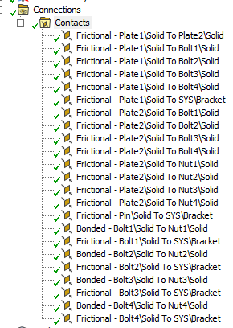

Figure 4. Connection tab and contact settings

For the third task, the tolerance was also adjusted to 0.01 mm, so that we can clearly analyze the contact regions.

The loadings were all different for three tasks, for the first task the forces were induced via bolt pretension.

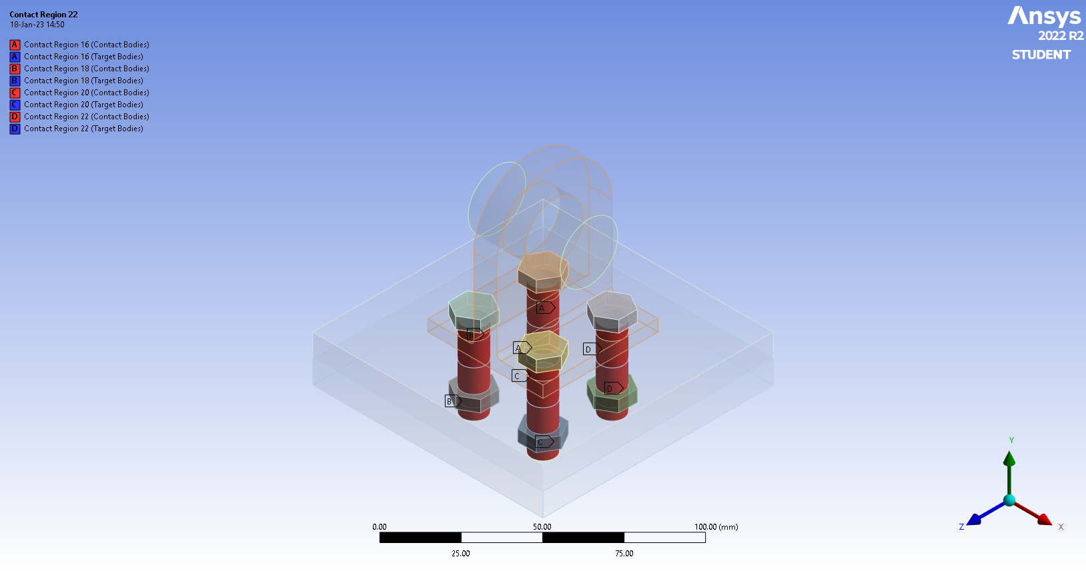

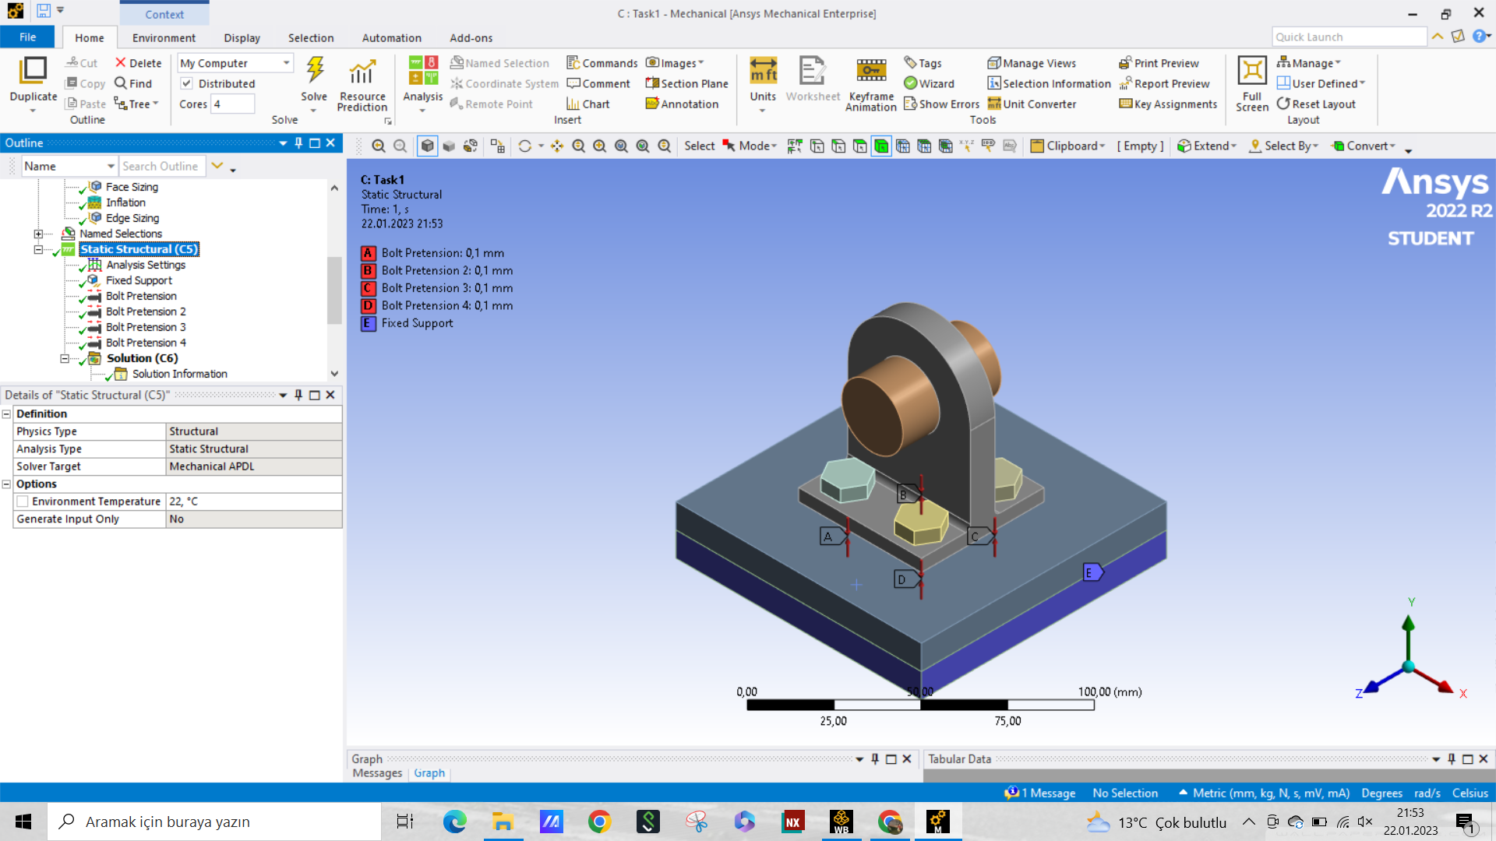

Figure 5. The bolt pretension was set to 0.1 mm for each individual bolt faces a) loading, b) boundary conditions

For the second task, the bolt pretensions were released and an external force of 10 kN was applied on the body sides of the pin.

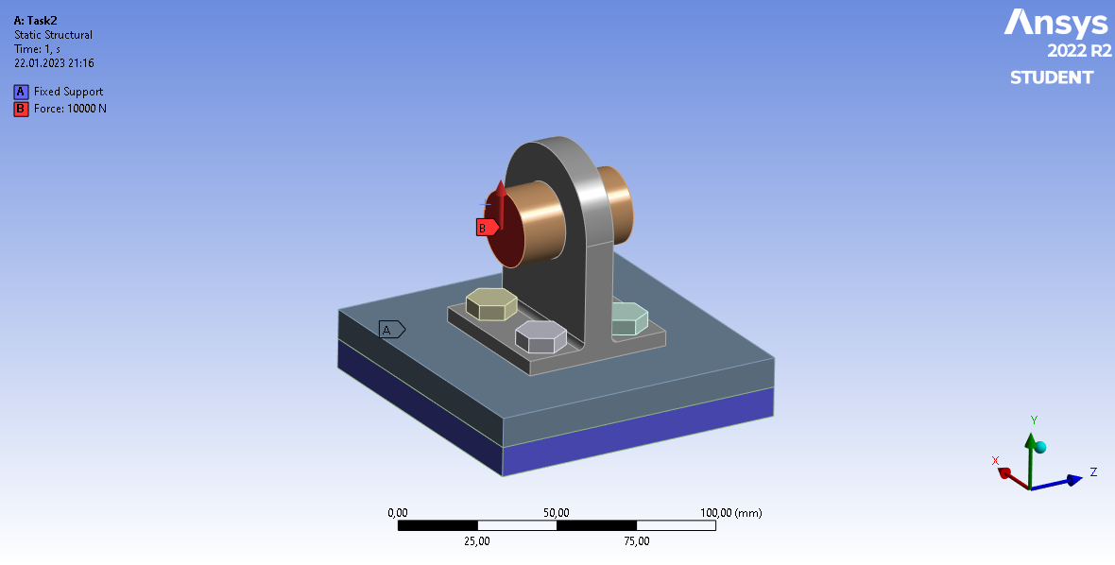

Figure 6. The external force acting on the pin

And for the third task, the same setup with the second task was used however, with different force values.

For the bonus part, the system was cut to half, therefore the external force was reduced by half as well to account for the missing part of the geometry.

**Solution and post-processing:** The model was solved then the results were visualized and interpreted, such as von Mises stress, displacement, and reaction forces. This step mainly involved the computation of equivalent stresses and the loadings occurring on different parts of the geometry. The stress values were calculated for each of the subsystem, and they were logged, so that a clear comparison between them could be done. Also for the third task, we analyzed the separation between the subsystems using the Contact tool and working loads on the bolts via the Bolt tool.

# Results

The results for the first part of the problem involves the equivalent stress in each element within the system. The stresses were induced purely due to the bolt pretension, meaning the compressive force between the nut and the bolt head.

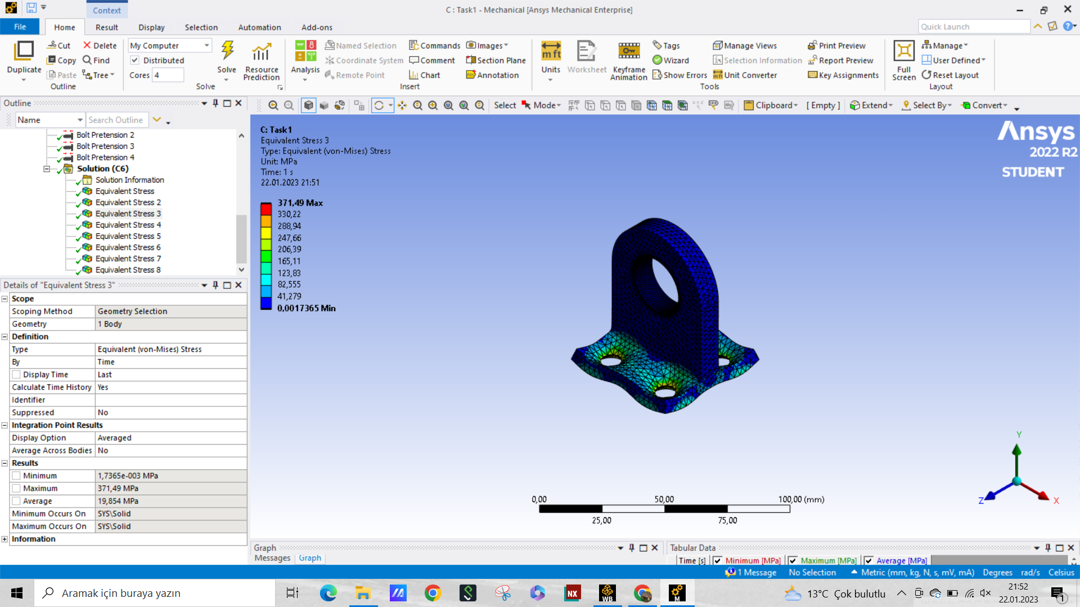

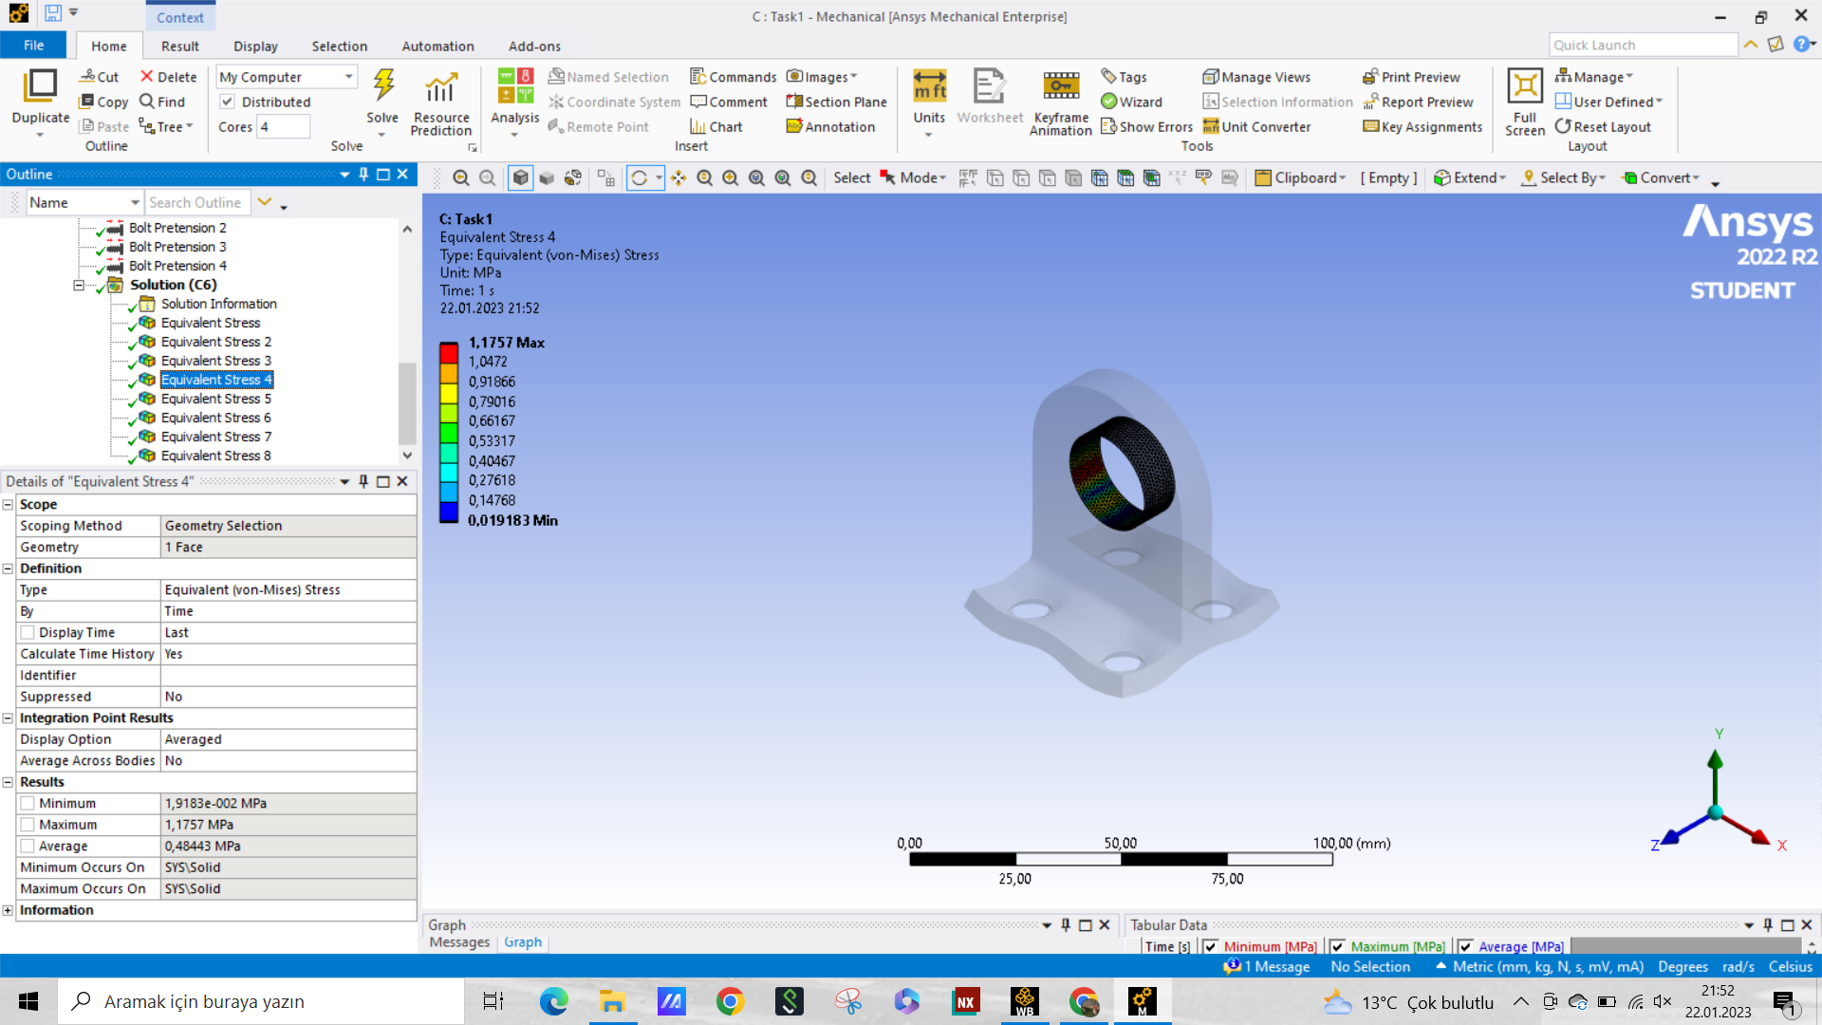

Figure 7. The equivalent stress on the Bracket, a) whole bracket, b) the contact region

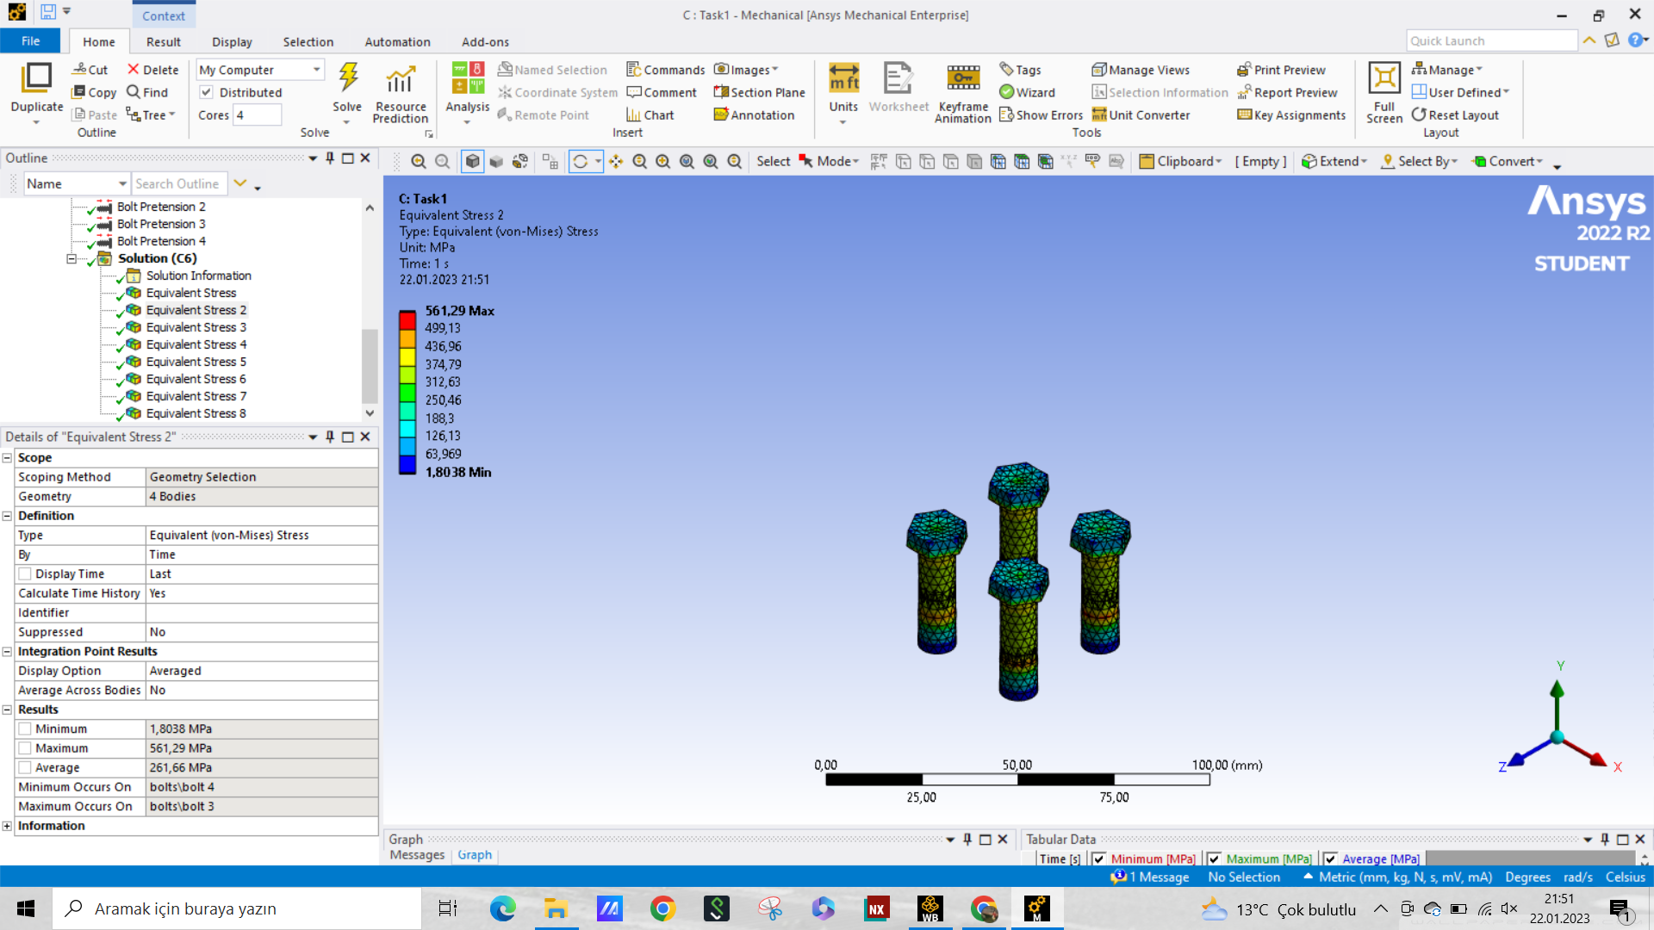

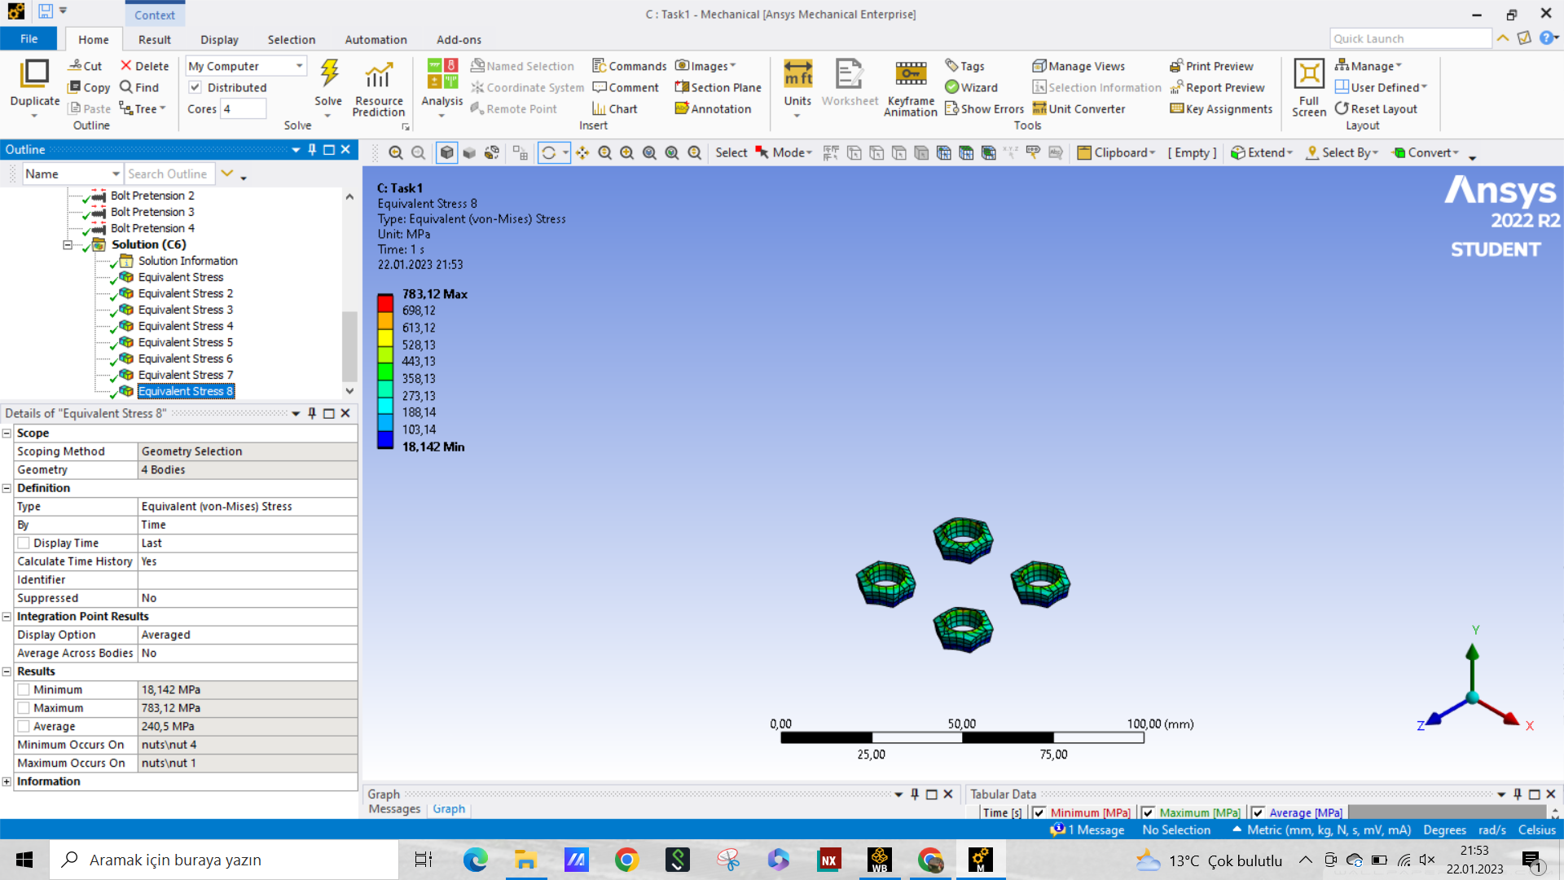

Figure 8. The equivalent stress on the a) bolts, b) nuts

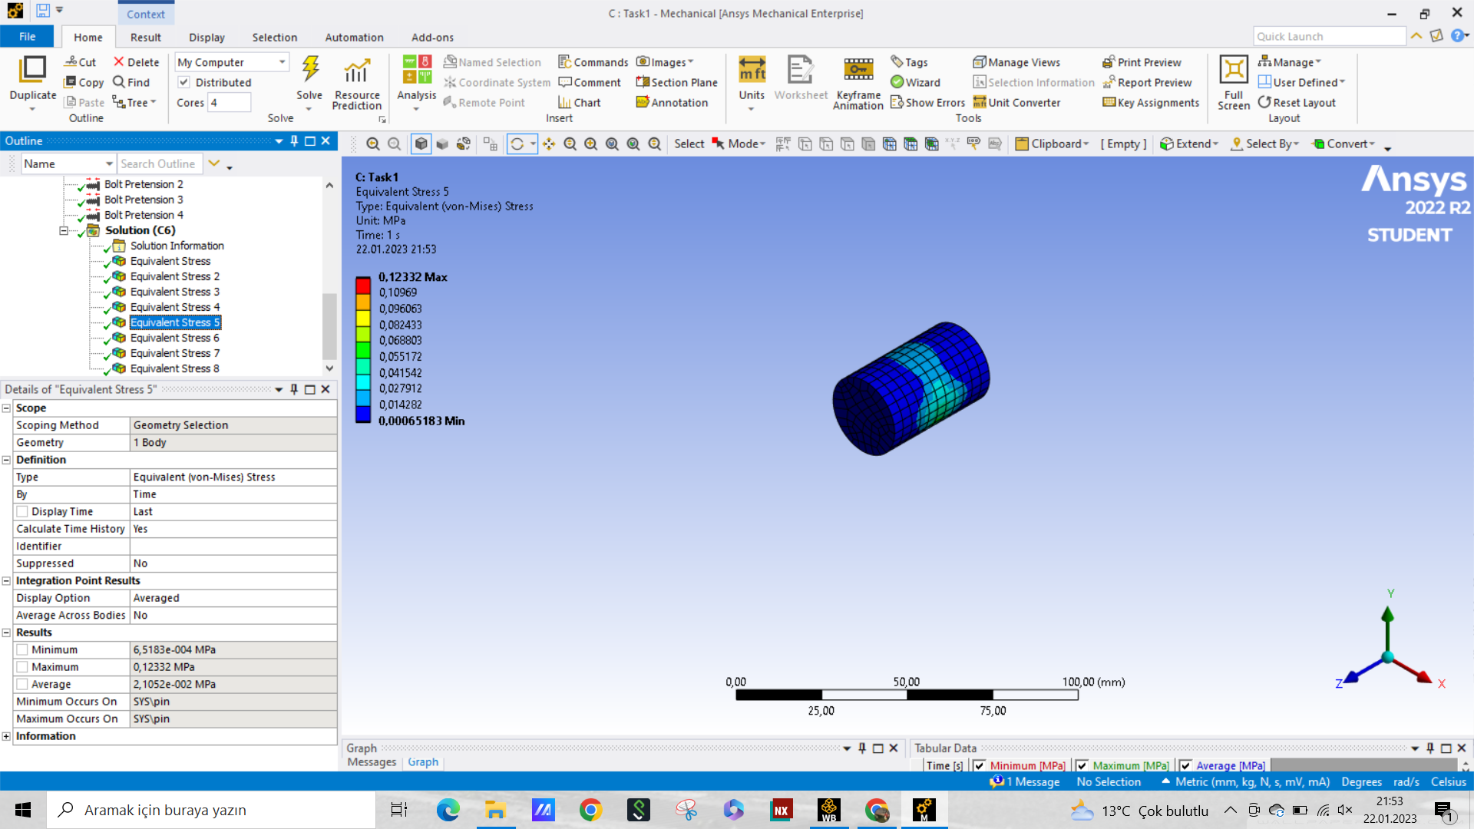

Figure 9. The equivalent stress on the pin

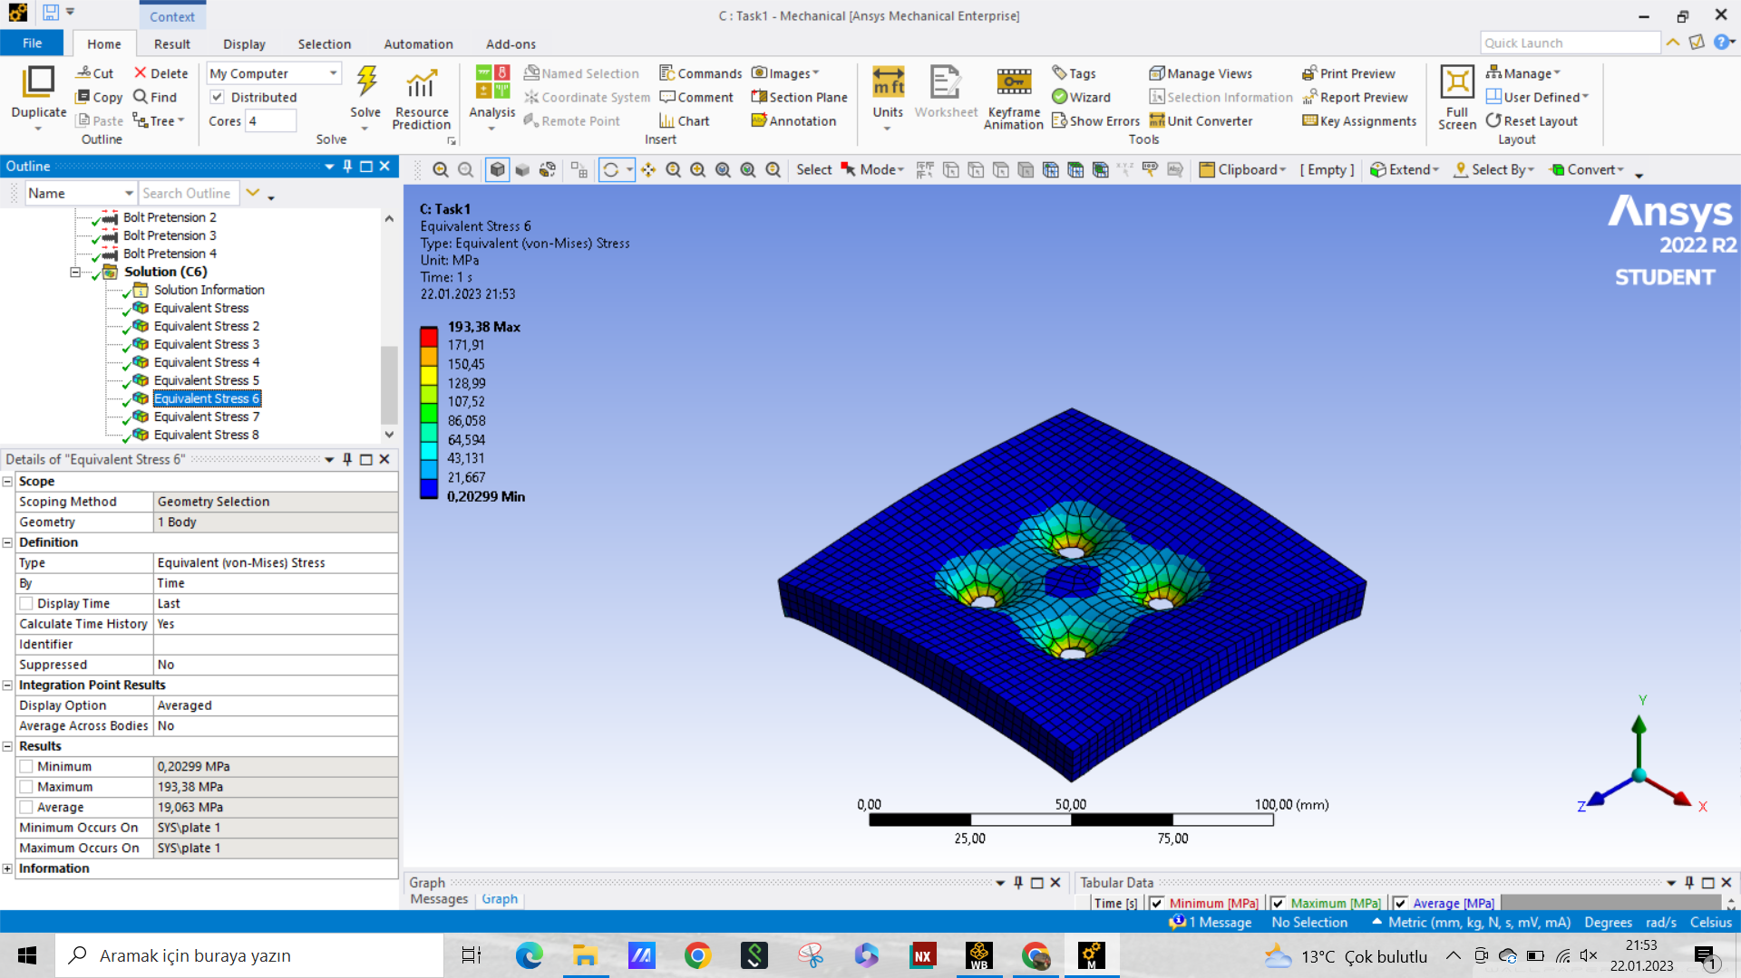

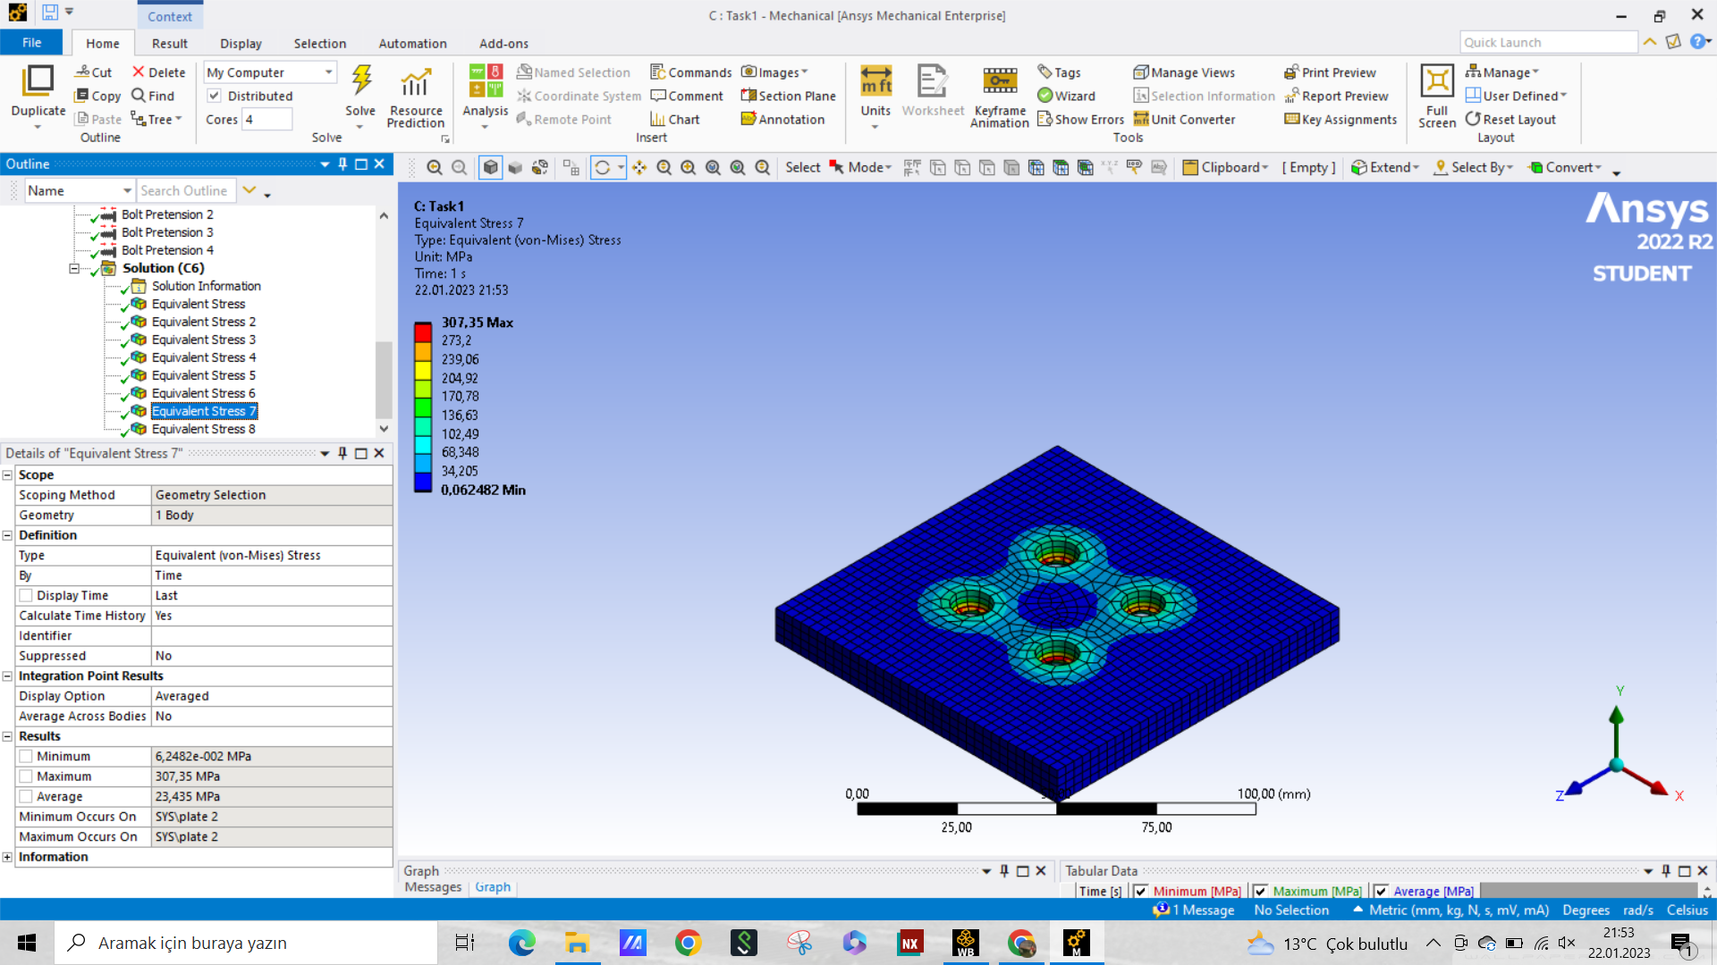

Figure 10. The equivalent stress on the plates, a) upper plate, b) lower plate

**Table 1. The calculated stresses on each part of the geometry in Task 1**

| **Part Name** | **Average Stress (MPa)** | **Maximum Stress (MPa)** |
| --- | --- | --- |
| Bolts | 261.7 | 561.3 |
| Nuts | 240.5 | 783.1 |
| Bracket | 19.9 | 371.5 |
| Pin | 0.0 | 0.1 |
| Upper Plate | 19.0 | 193.4 |
| Lower Plate | 23.4 | 307.4 |

For the second task, the loadings were purely due to the external force and the system was analogous to the pin-loaded hole plate scenario that was discussed in the class and characterized by Figure 4.40 in the book.

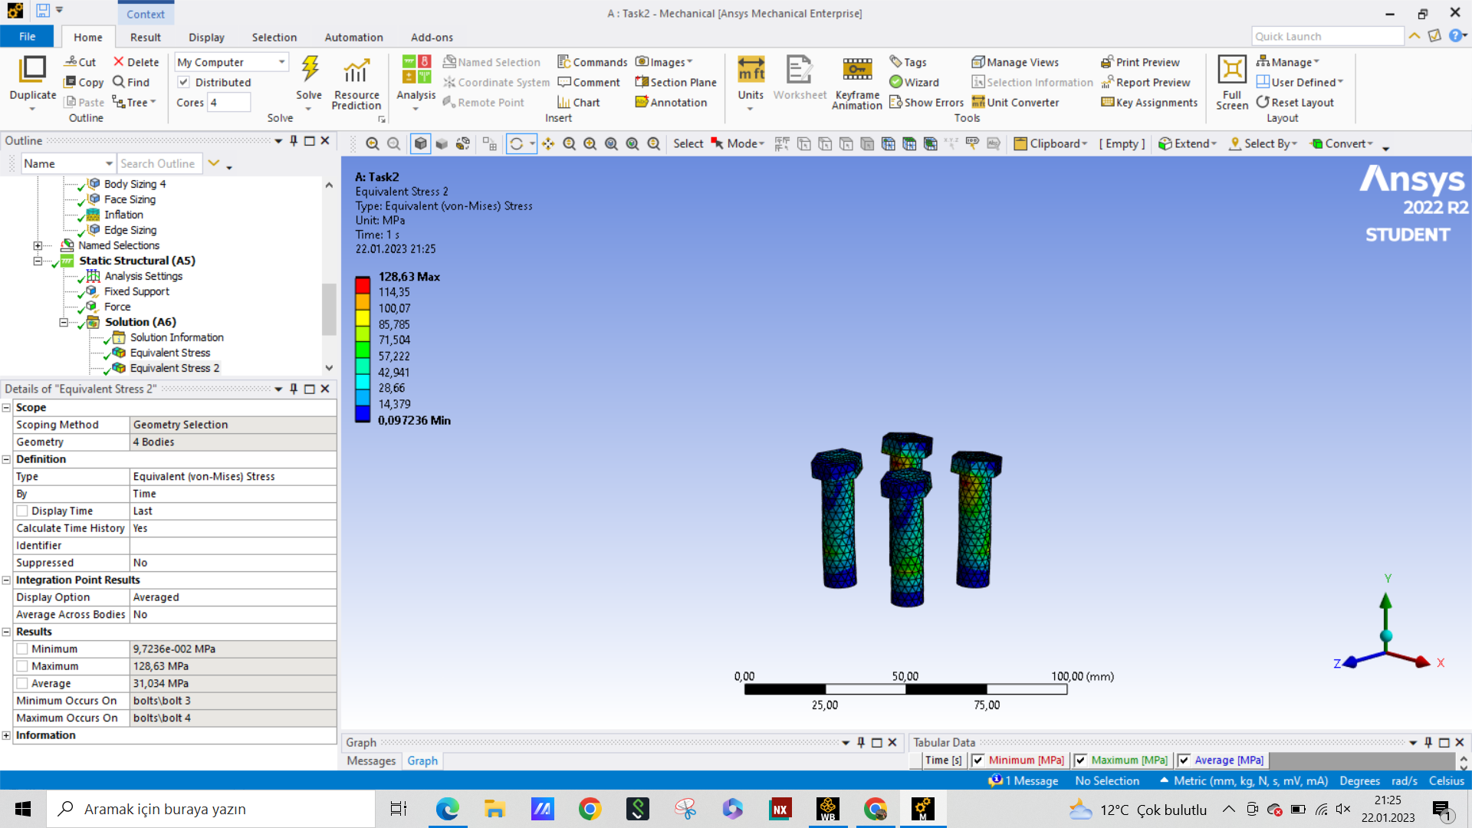

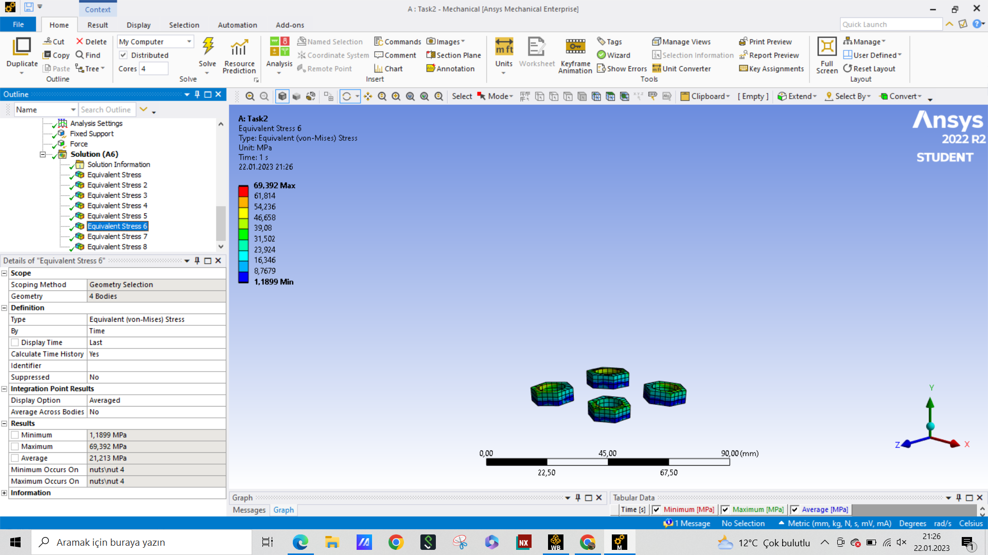

Figure 11. The equivalent stress on the a) bolts, b) nuts

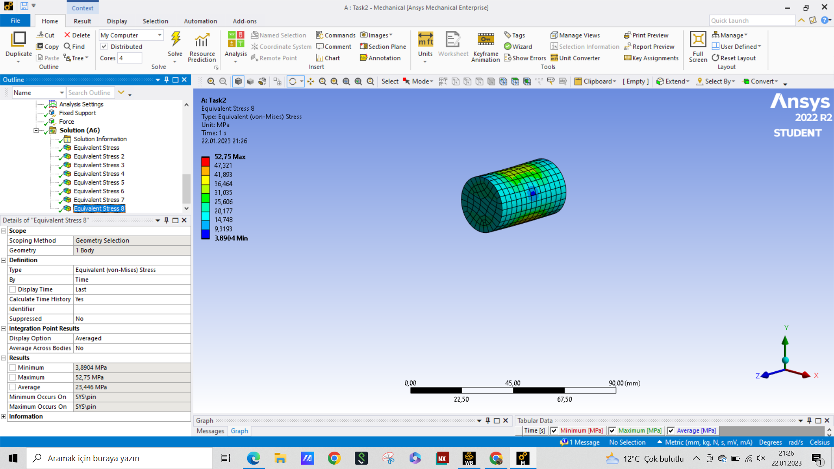

Figure 12. The equivalent stress on the pin

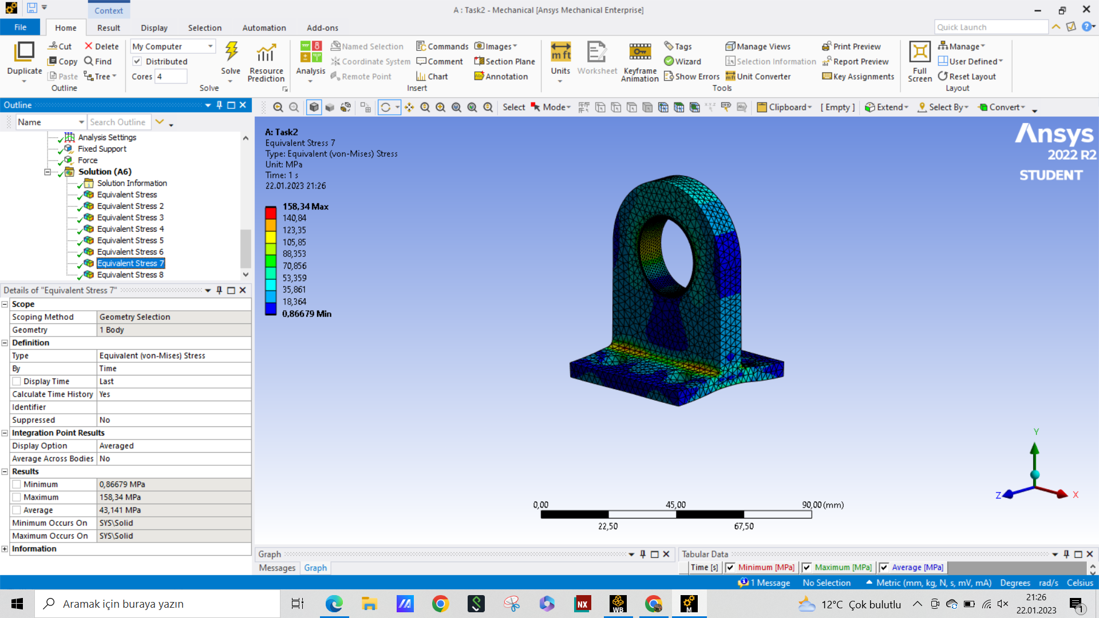

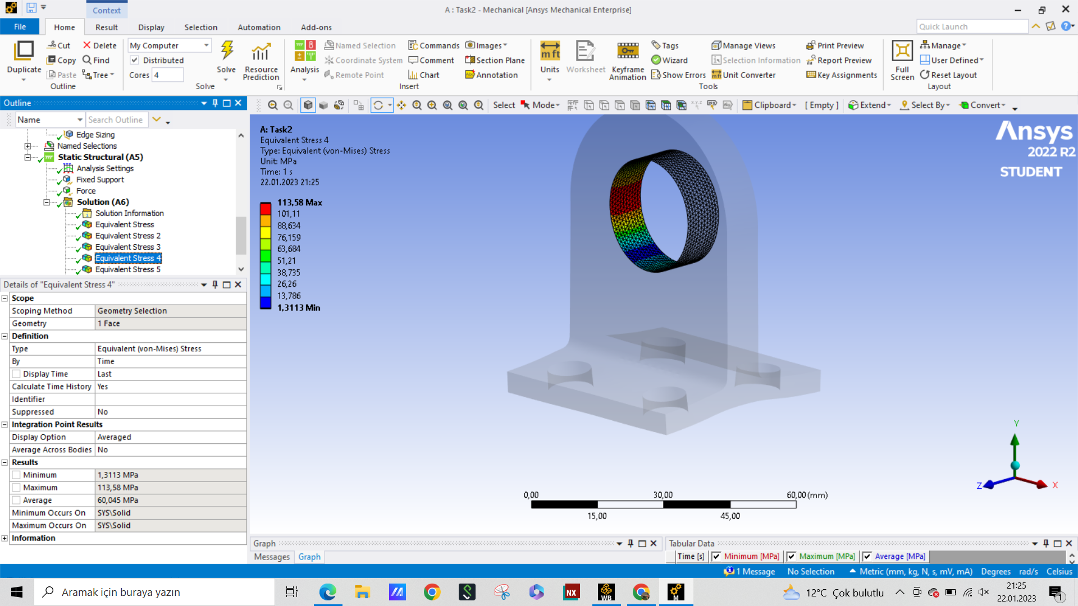

Figure 13. The equivalent stress on the Bracket, a) whole bracket, b) the contact region

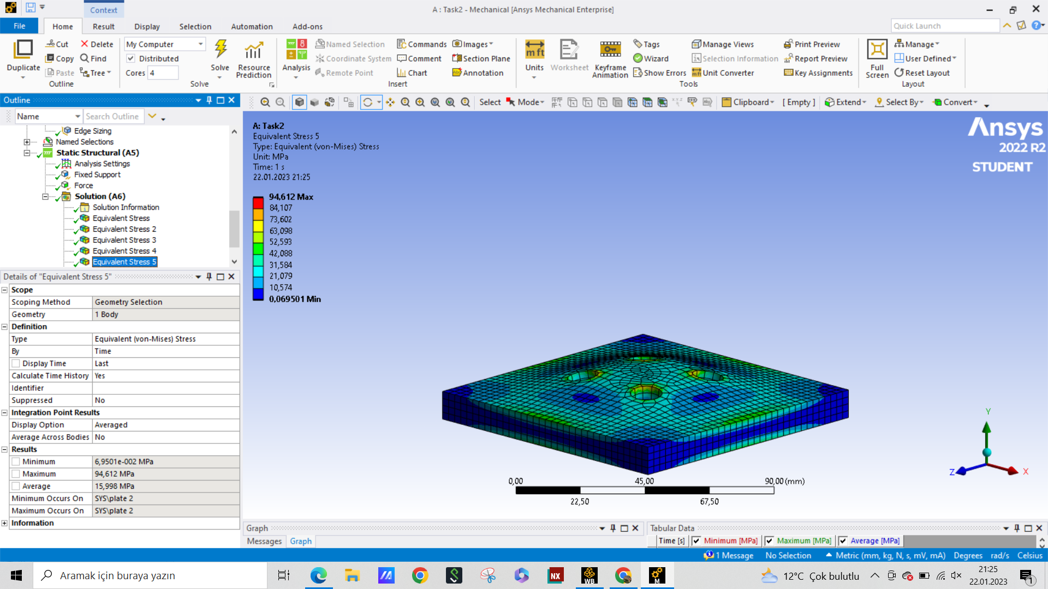

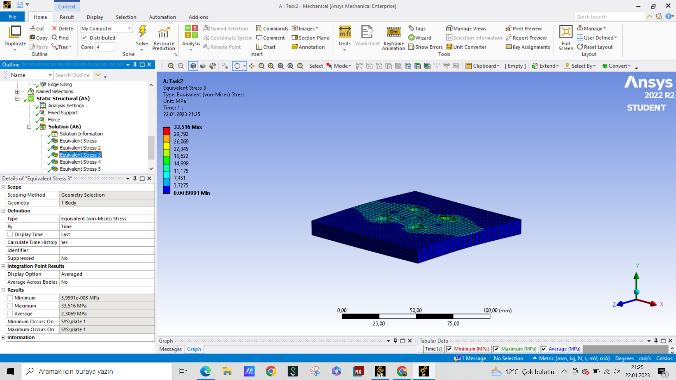

Figure 14. The equivalent stress on the plates, a) upper plate, b) lower plate

**Table 2. The calculated stresses on each part of the geometry in Task 2**

| **Part Name** | **Average Stress (MPa)** | **Maximum Stress (MPa)** |
| --- | --- | --- |
| Bolts | 31.0 | 128.6 |
| Nuts | 1.9 | 69.4 |
| Bracket | 43.1 | 158.3 |
| Pin | 23.4 | 52.7 |
| Upper Plate | 16.0 | 94.6 |
| Lower Plate | 2.3 | 33.5 |

And specifically for the bracket contact face, the stresses are in Table 3. The average and the maximum stress were obtained from ANSYS and the nominal stress was found by using the external force and the axial loading formula for the pin-loaded hole setup, as follows,

$σ_{nom}=\frac{F}{(b-d)h}=\frac{10 kN}{(50 mm-25 mm)⋅10 mm}$

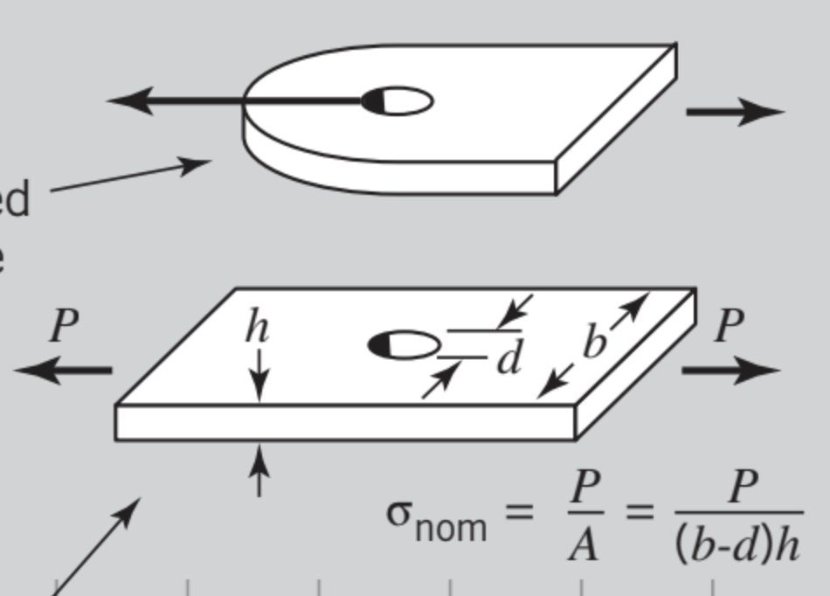

Figure 15. Pin-loaded hole nominal stress calculation [1]

**Table 3. The calculated stresses on the contact face in Task 2**

| **Average Stress (MPa)** | **Maximum Stress (MPa)** | **Nominal Stress (MPa)** | **Stress Concantration Factor** |
| --- | --- | --- | --- |
| 31.0 | 113.6 | 40.0 | 2.84 |

For the third task, the same loading scenario with the second task was applied but with a different force. The general stresses of each subsystem will be the same as the second task, therefore don’t need their own graph. However, since the forces are different the separation graphs and the stress values will be different while holding the same trends.

For this task, I used 4 different loading magnitudes: {5kN, 15kN, 50kN, 100kN}

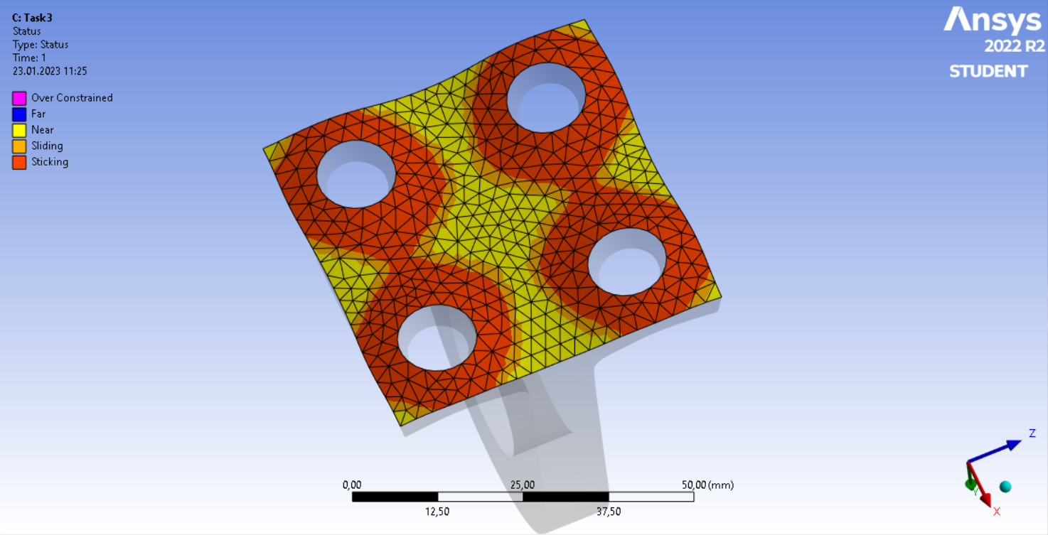

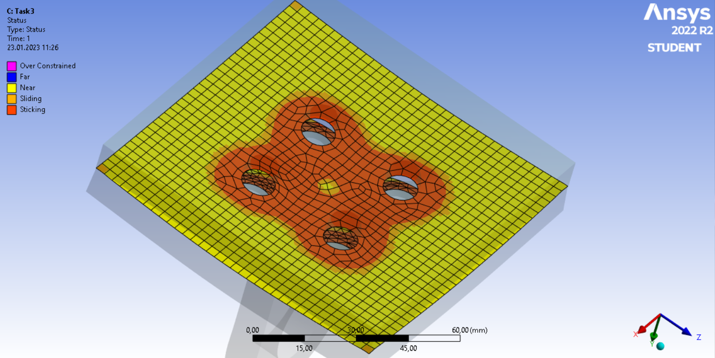

Figure 16. The contact geometry when F= 5kN, a) Bracket-Top Plate, b) Between Plates

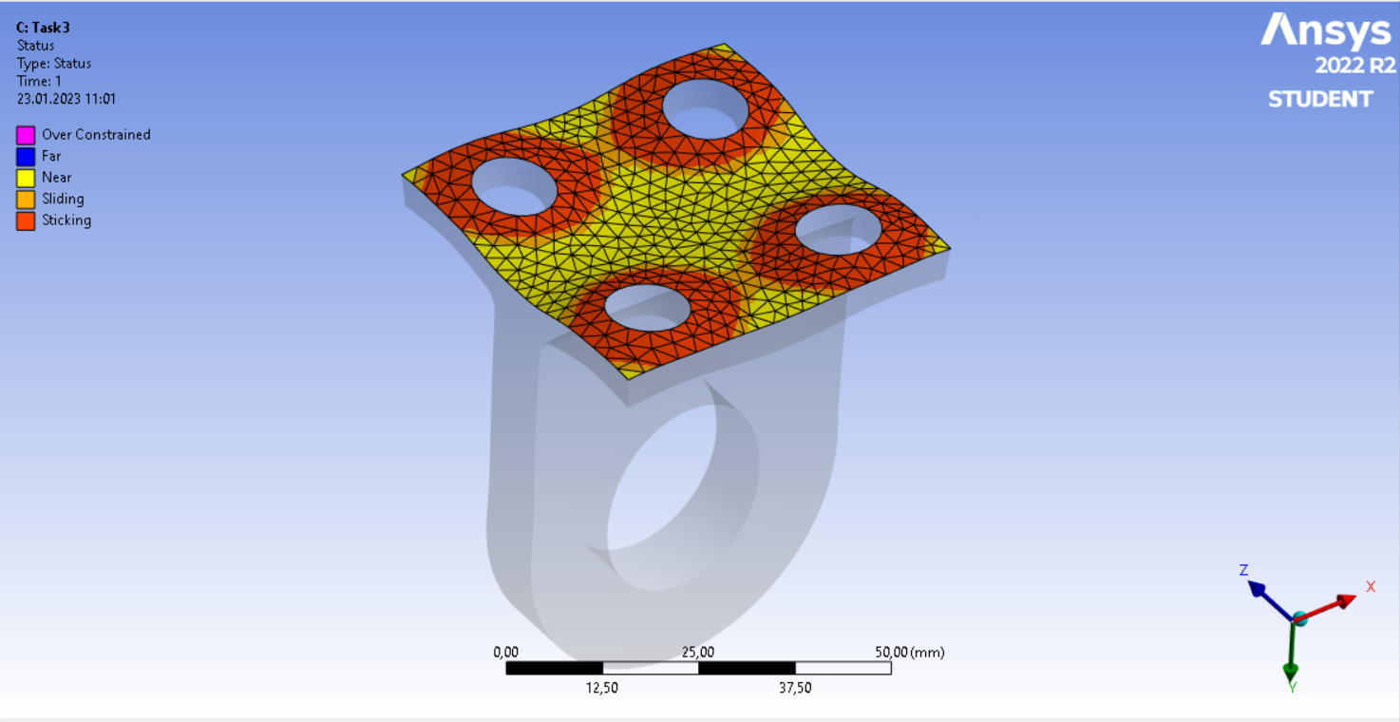

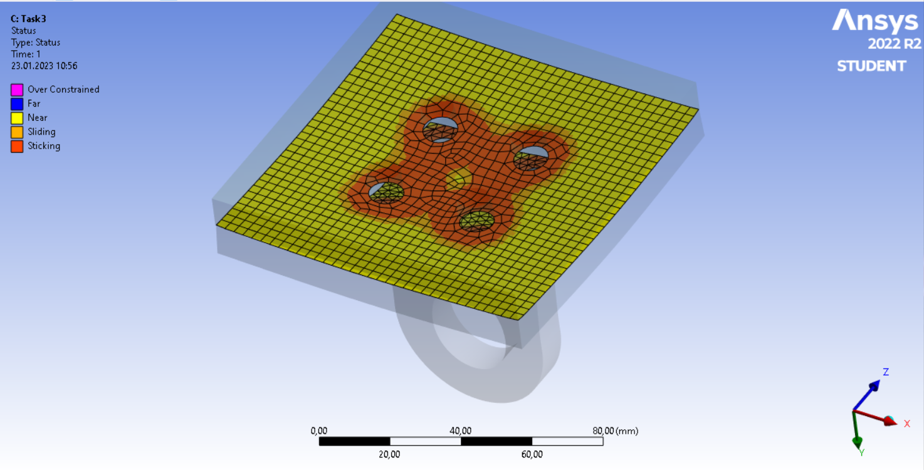

Figure 17. The contact geometry when F= 10kN, a) Bracket-Top Plate, b) Between Plates

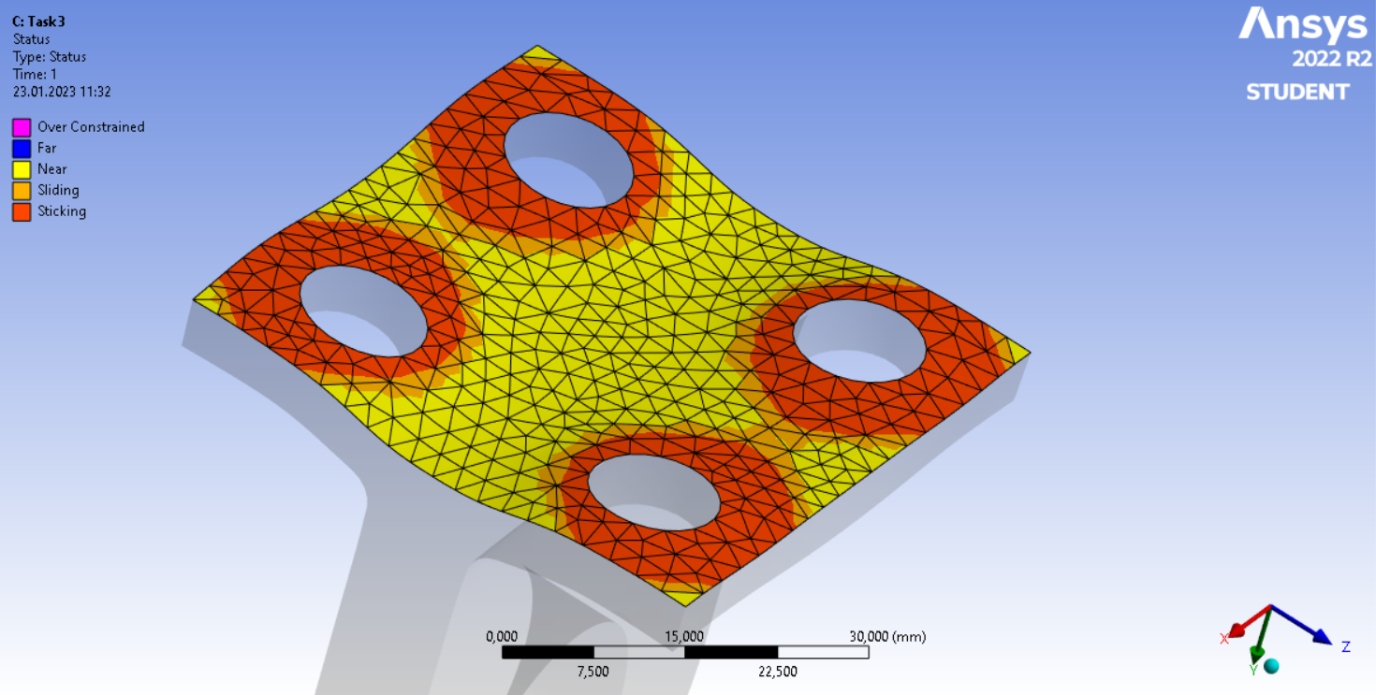

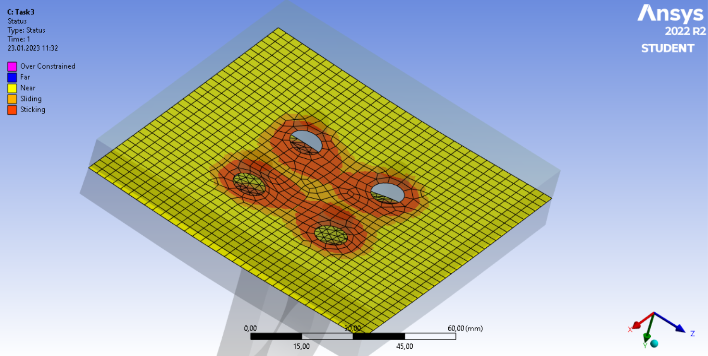

Figure 18. The contact geometry when F= 15kN, a) Bracket-Top Plate, b) Between Plates

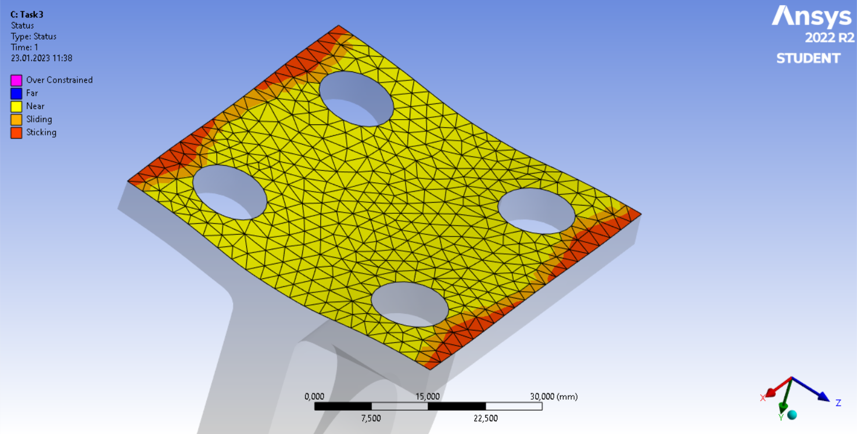

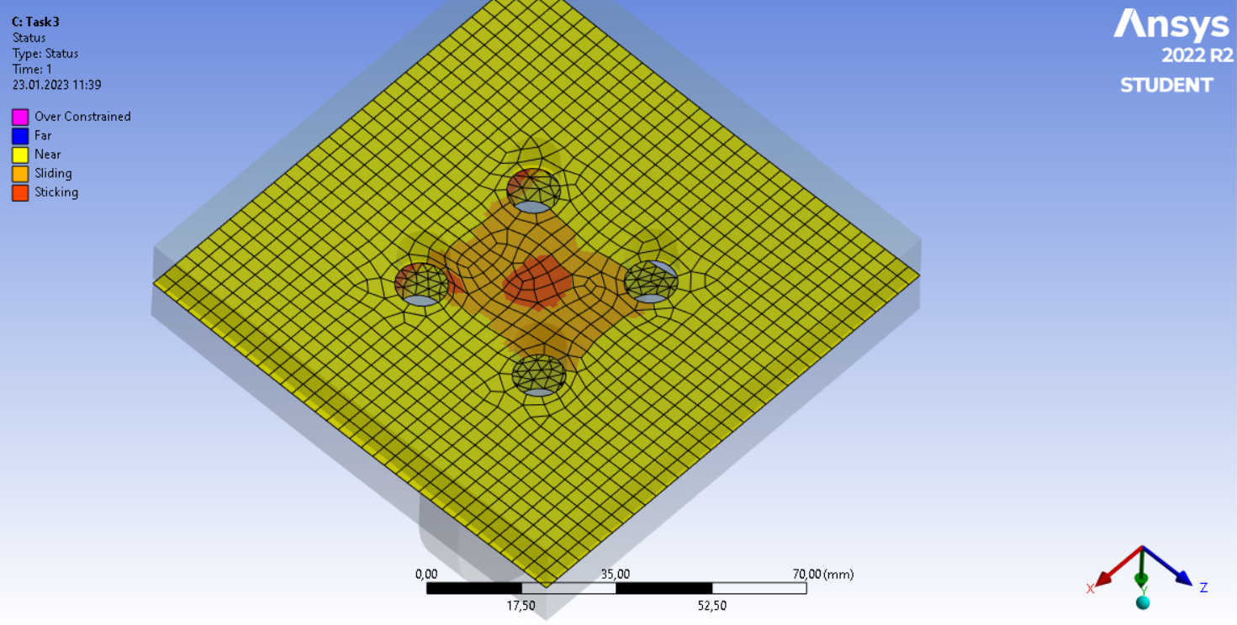

Figure 19. The contact geometry when F= 100kN, a) Bracket-Top Plate, b) Between Plates

As can be seen from the figures, as the externally applied force increases the darker region between the plates which corresponds to sliding and sticking decreases, and the lighter region corresponding to separation increases. This is due to the external force overcoming the clamping force of the bolts. The graphical results are very intuitive.

Due to the changing external force, the clamping force and the bolt working load also changes. In this study, we aimed to find the relationship between the working load and the external force, and the working load values on the bolts, the results are in Table 4.

**Table 4. The effect of external force on the working load of the bolts**

| **External Force (kN)** | **Working Load (MPa)** |
| --- | --- |
| 5 | 13.2 |
| 10 | 13.3 |
| 15 | 13.4 |
| 100 | 30.96 |

As can be seen, as the external force increases the working load of the bolts also increases. This was also discussed in class and is theoretically accurate.

For the bonus part of the project, the geometry was cut in half in the SpaceClaim app. Later in the ANSYS, special arrangements were made to introduce the symmetry plane to the solver. To achieve this we have created symmetry conditions for each body using the face on the symmetry plane. As a result, the number of elements also drops by half.

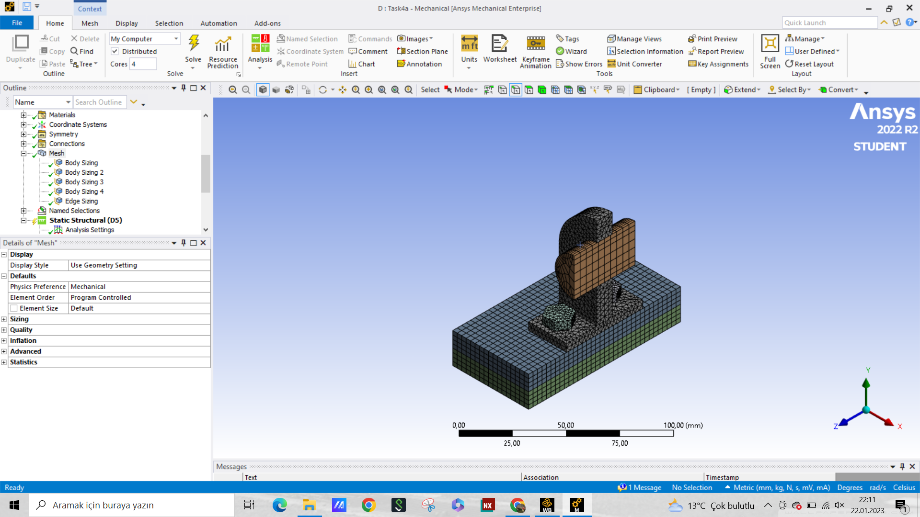

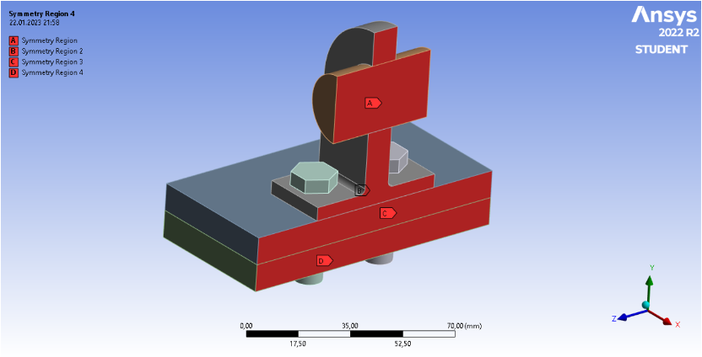

Figure 20. Half of the geometry with a mid-section symmetry, a) the meshing, b) symmetry region definitions

For the first task, we conducted the exact same study and got the following results,

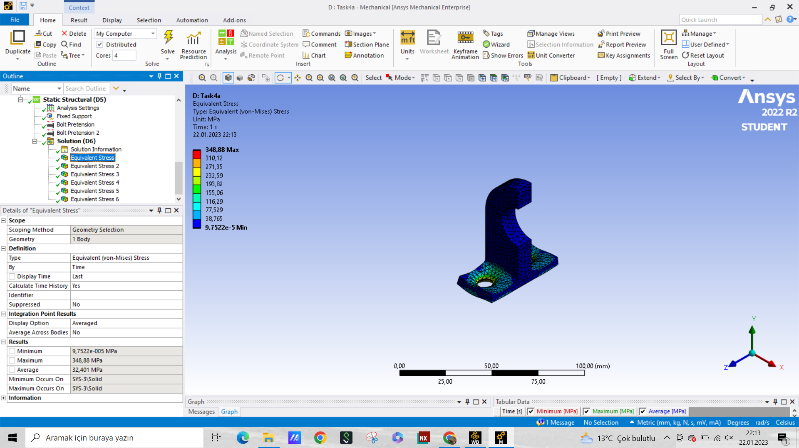**Figure 2**1**.** The loading on the Bracket with half geometry

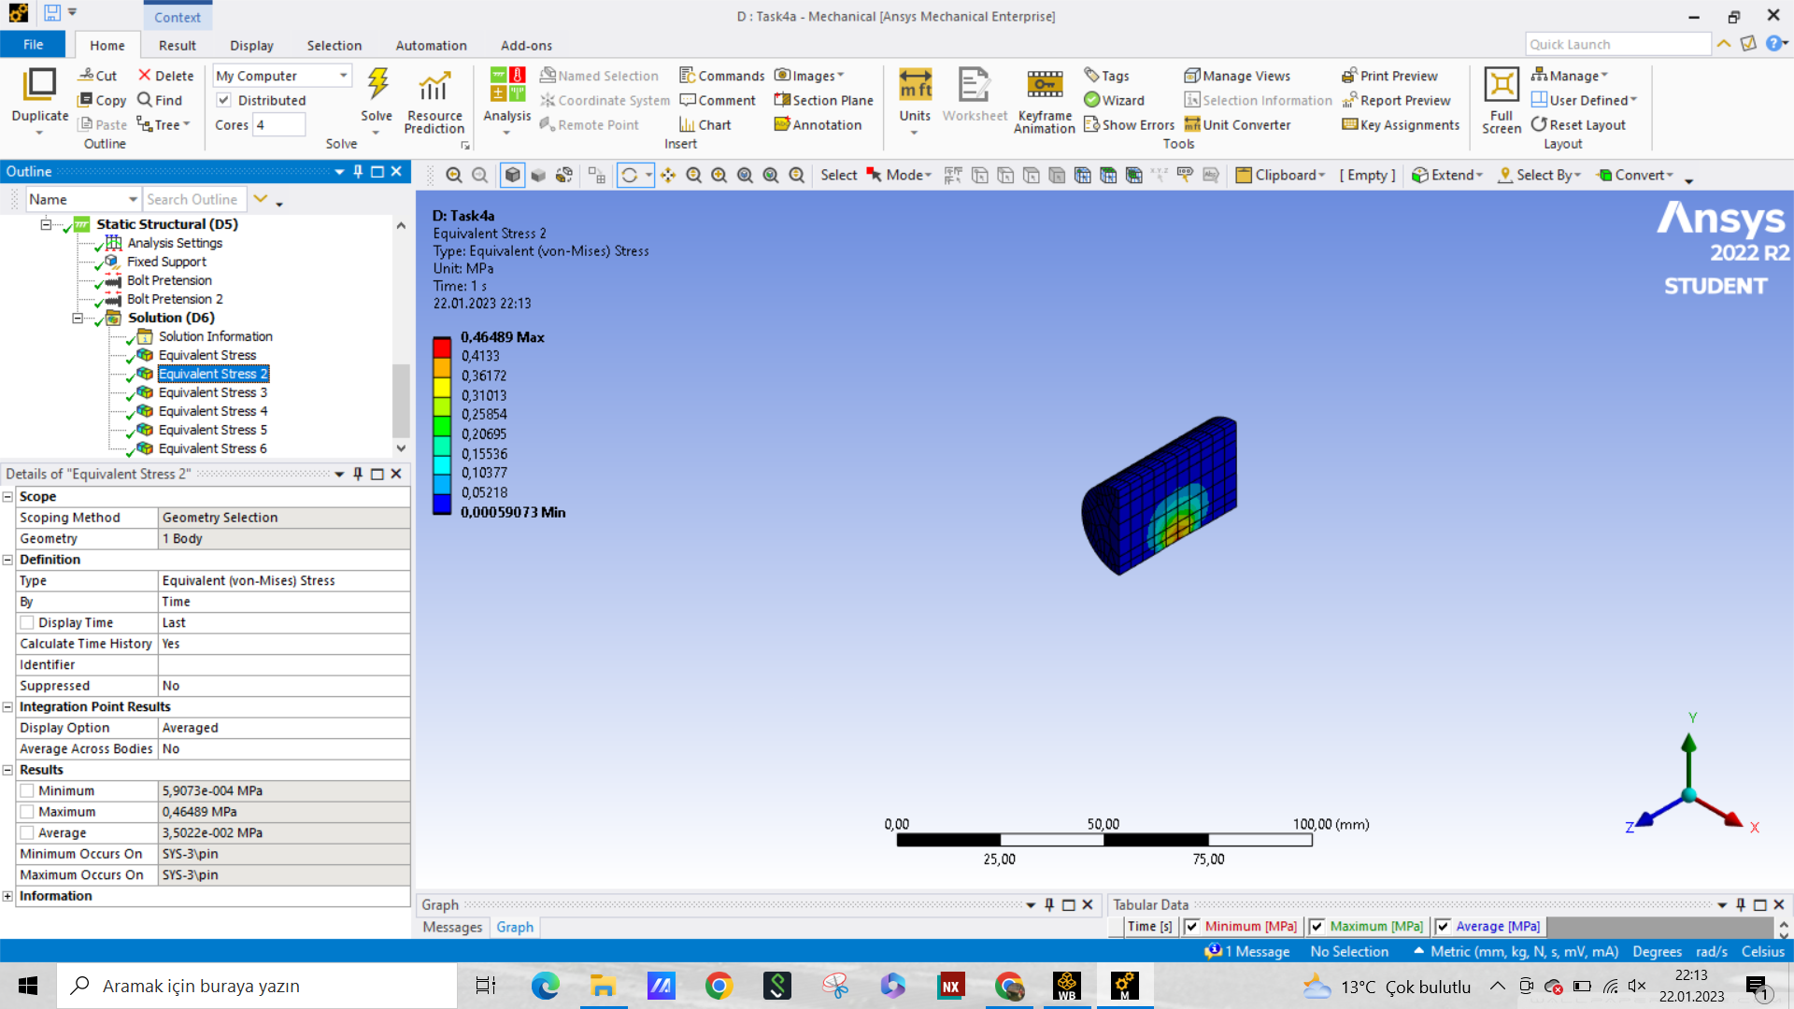Figure 22. The loading on the pin with half geometry

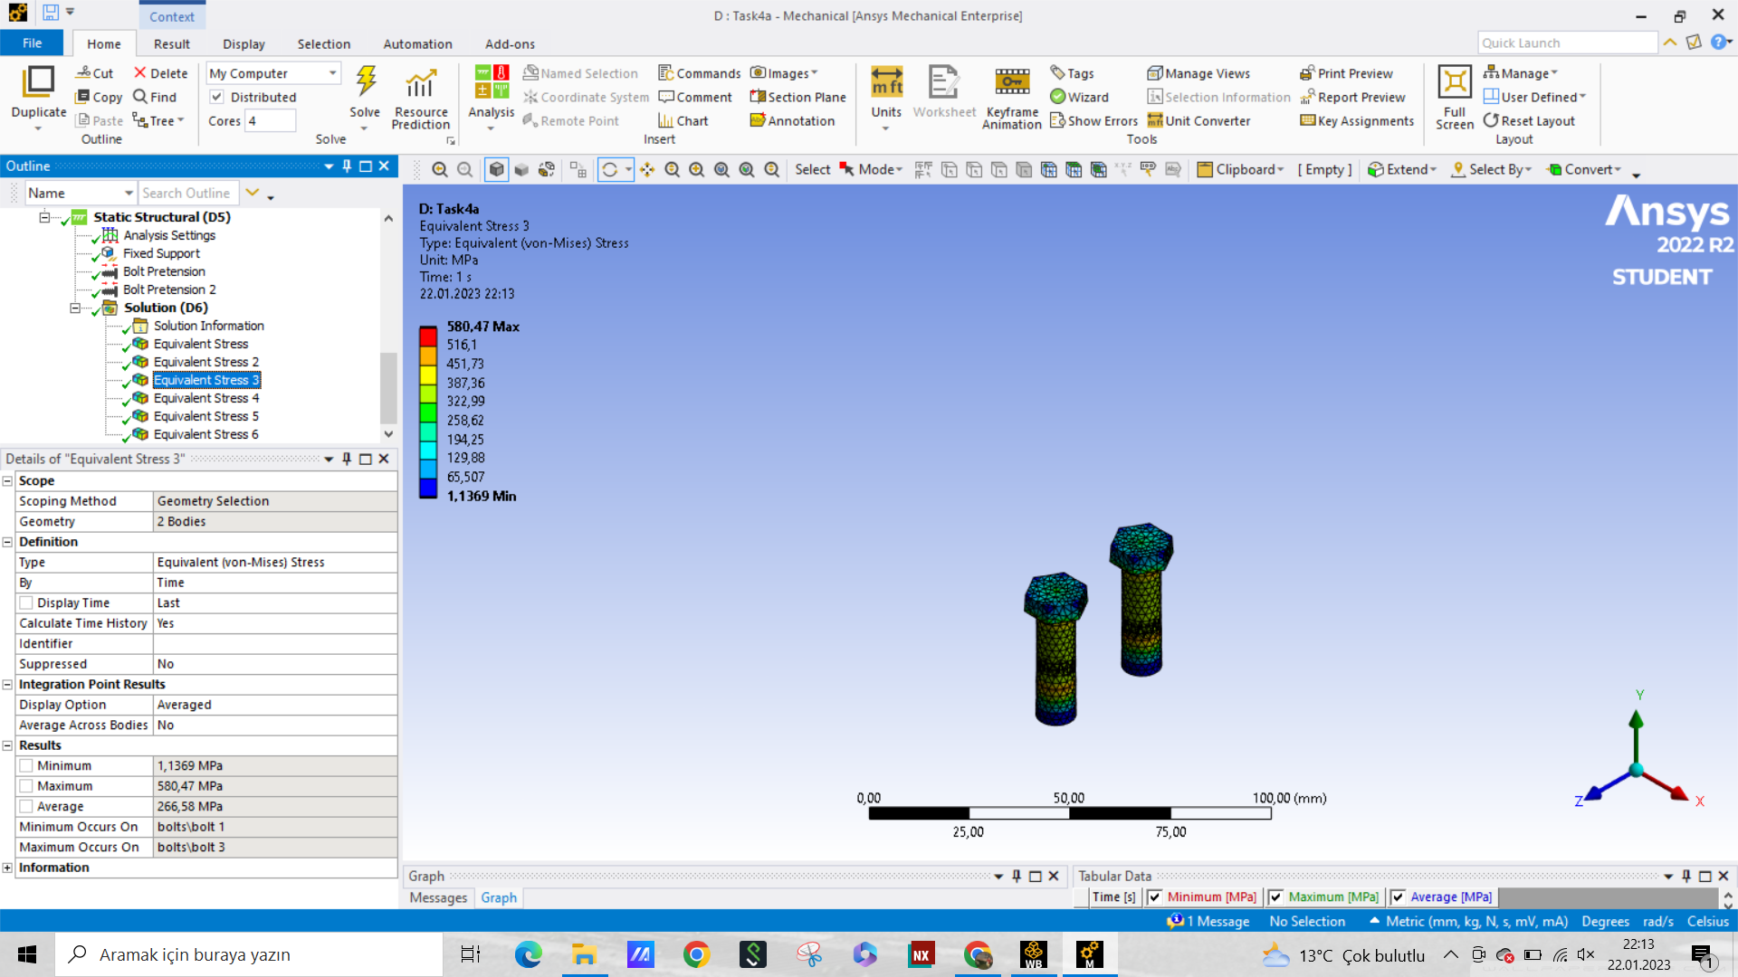

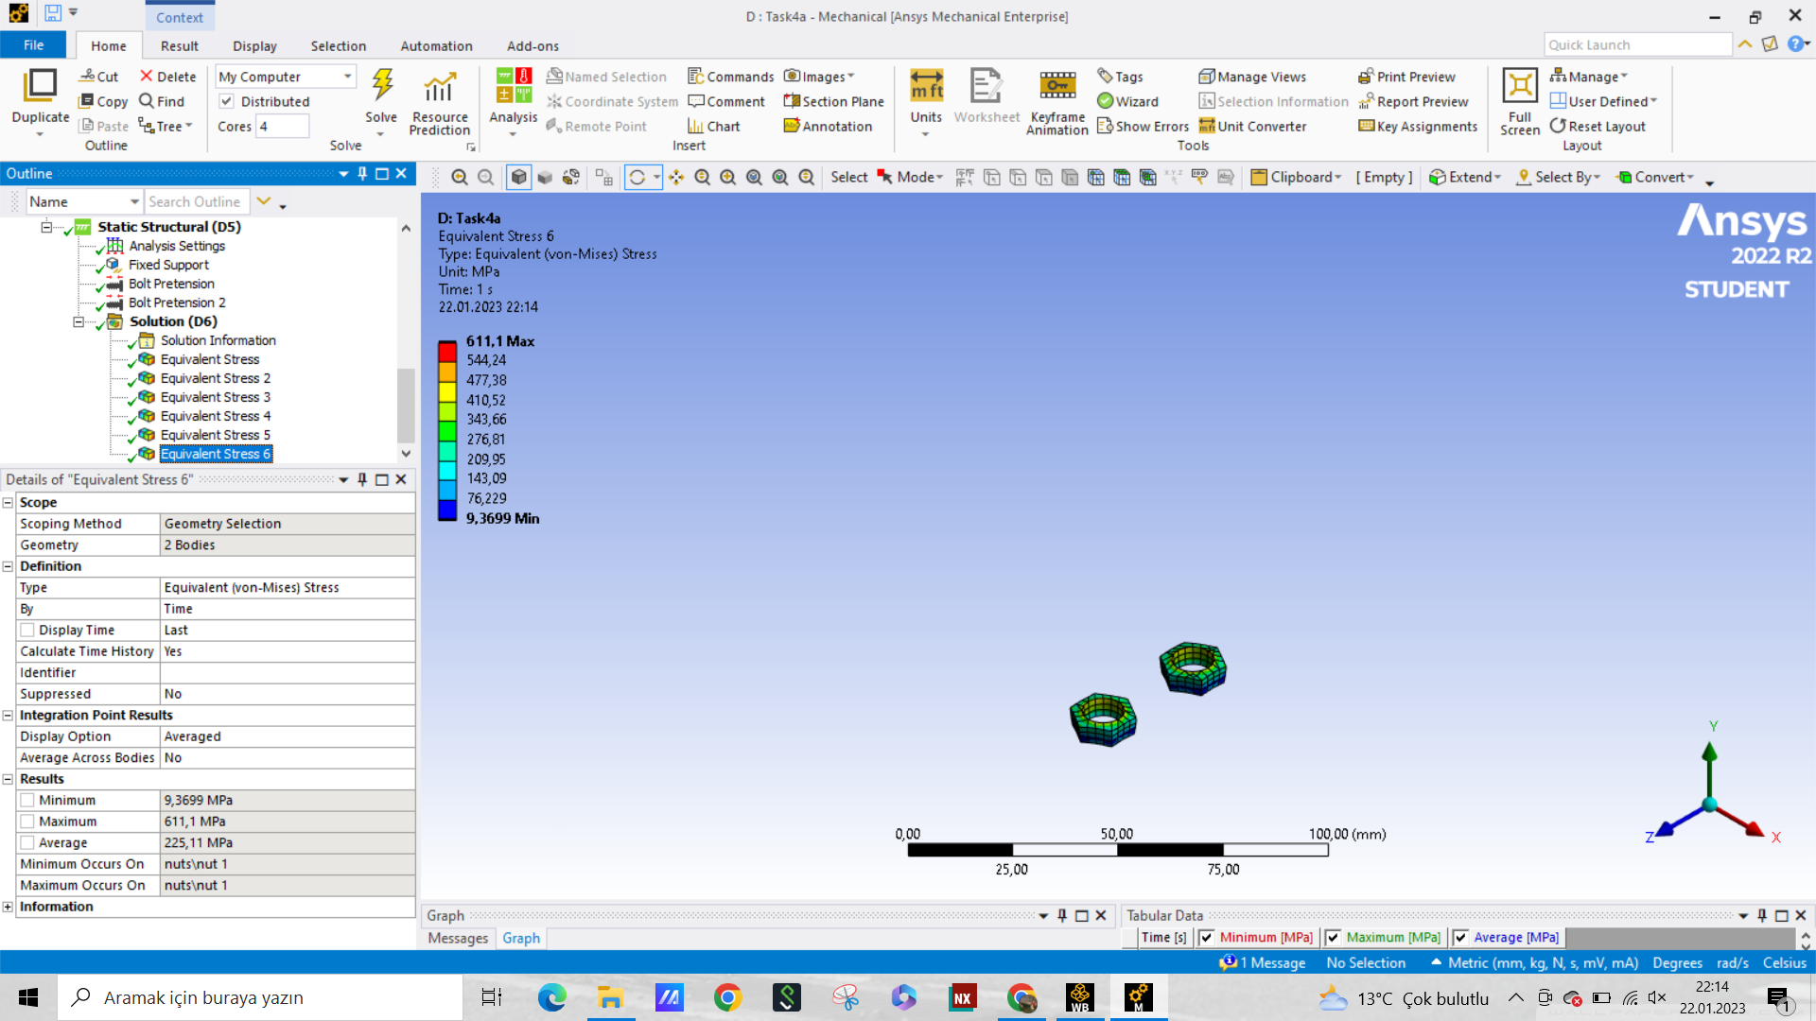

Figure 23. The loading on the a) bolts, b) nuts

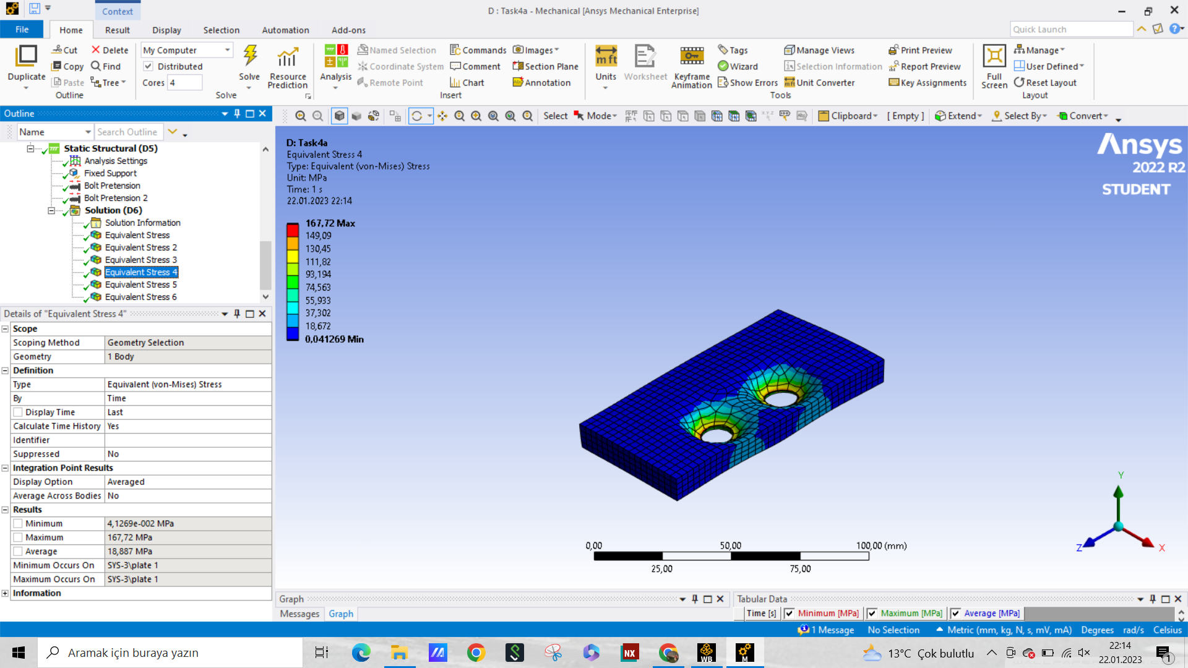

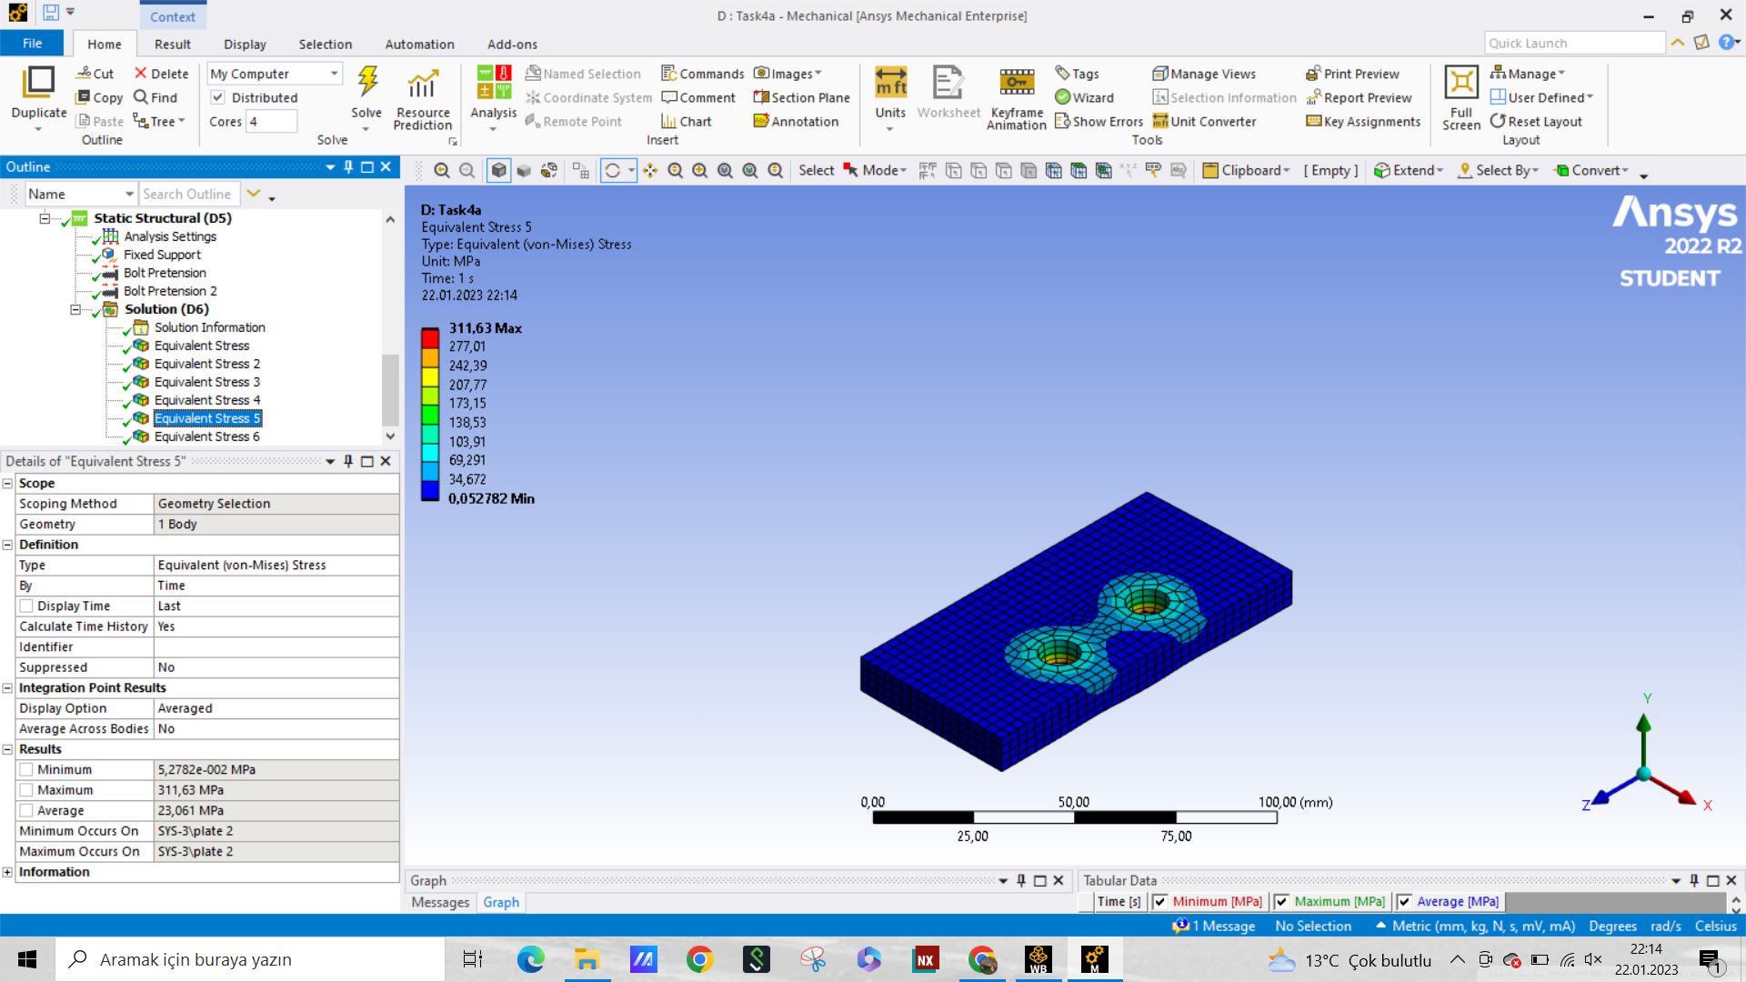

Figure 24. The loading on the a) top plate, and b) bottom plate

And when the stresses are tabulated, the results are as follows,

**Table 5. The calculated stresses on each part of the geometry in Task 2 compared to the whole geometry, where the first stress is whole and the second is half geometry**

| **Part Name** | **Average Stress (MPa)** | **Maximum Stress (MPa)** |
| --- | --- | --- |
| Bolts | 261.7 - 266.6 | 561.3 - 580.5 |
| Nuts | 240.5 - 225.1 | 783.1 - 611.1 |
| Bracket | 19.9 - 32.4 | 371.5 - 348.9 |
| Pin | 0.0 - 0.0 | 0.1 - 0.5 |
| Upper Plate | 19.0 - 18.9 | 193.4 - 167.7 |
| Lower Plate | 23.4 - 23.1 | 307.4 - 311.6 |

The values that we get for the half and whole geometries are very precise and the average deviation doesn’t exceed 5%. For the pin, since the numbers are very small, the error seems high but that is due to the nature of FEM solvers. Apart from that, the maximum error was on the upper plate.

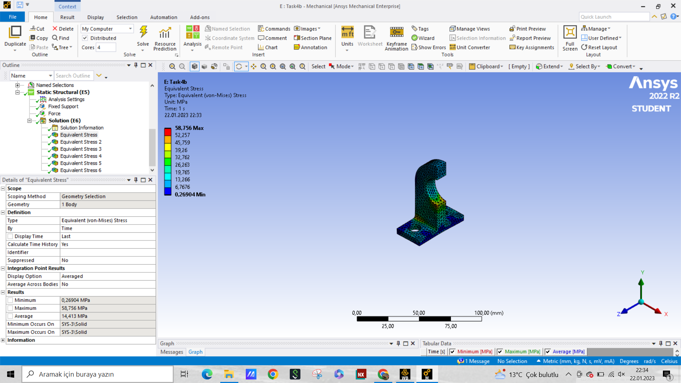Figure 25. The loading on the Bracket with half geometry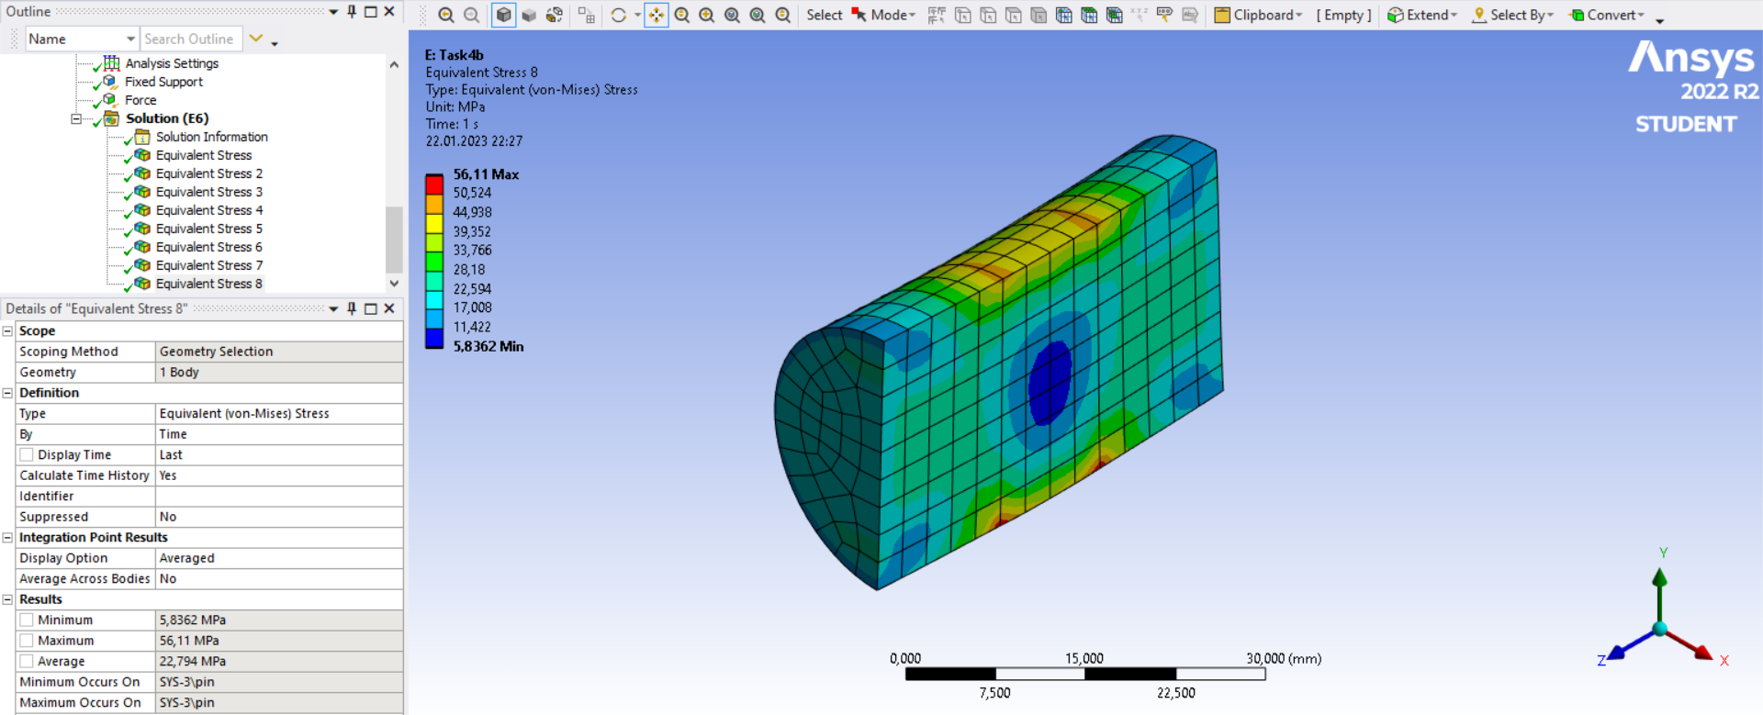Figure 26. The loading on the pin with half geometry

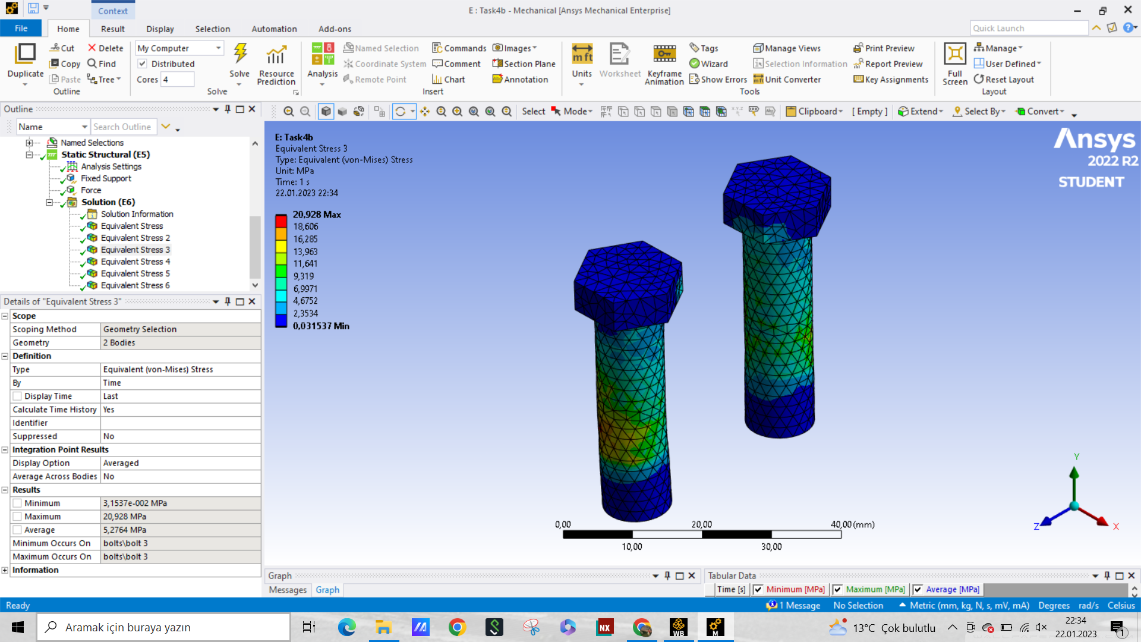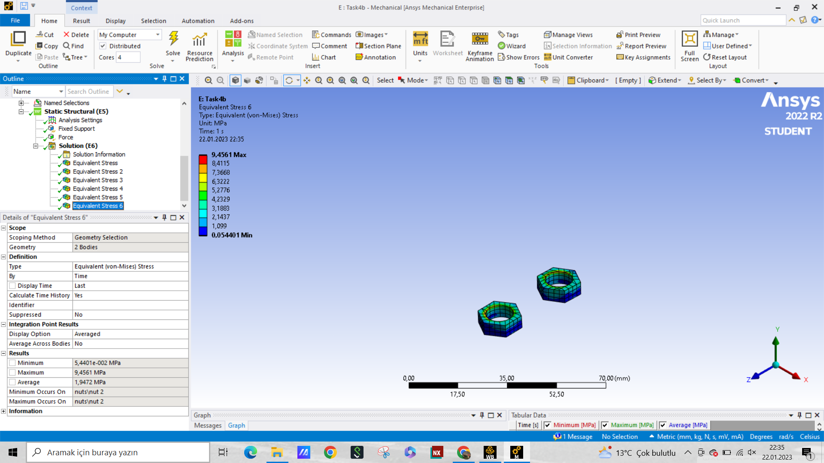

Figure 27. The loading on the a) bolts, and b) nuts

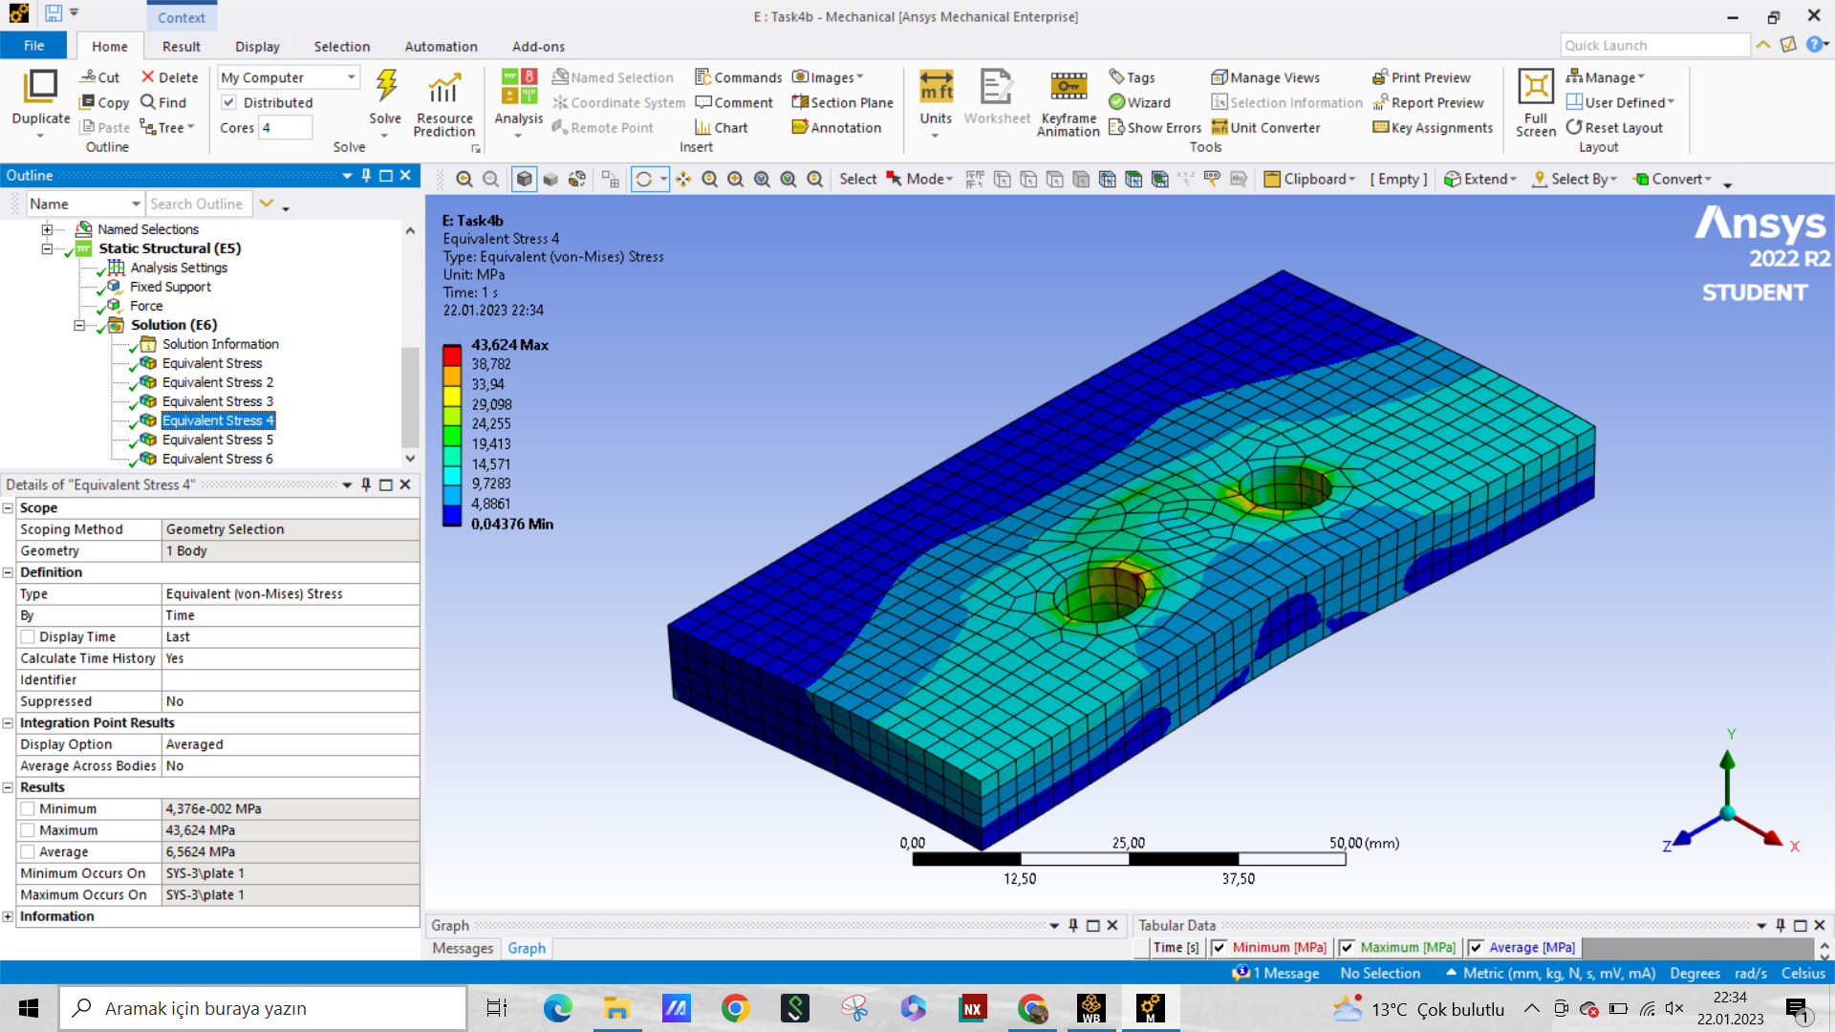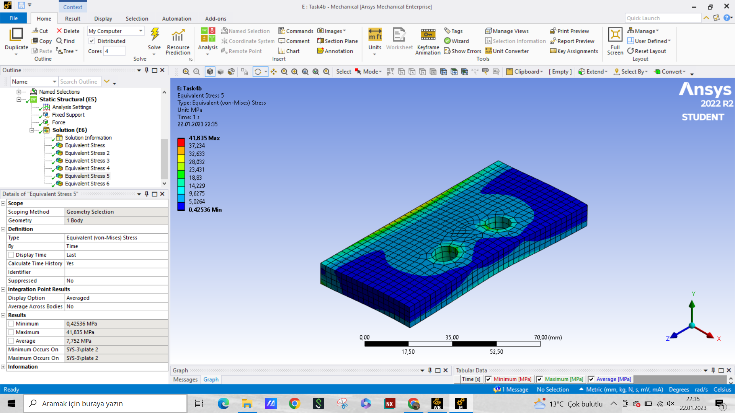

Figure 24. The loading on the a) top plate, and b) bottom plate

And when the stresses are tabulated, the results are as follows,

**Table 6. The calculated stresses on each part of the geometry in Task 2 compared to the whole geometry, where the first stress is whole and the second is half geometry**

| **Part Name** | **Average Stress (MPa)** | **Maximum Stress (MPa)** |
| --- | --- | --- |
| Bolts | 31.0 - 5.3 | 128.6 - 20.9 |
| Nuts | 1.9 - 1.9 | 69.4 - 9.5 |
| Bracket | 43.1 - 14.4 | 158.3 - 58.8 |
| Pin | 23.4 - 22.8 | 52.7 - 56.1 |
| Upper Plate | 16.0 - 6.6 | 94.6 - 43.6 |
| Lower Plate | 2.3 - 0.4 | 33.5 - 41.8 |

As in the Task 2, we can again use the maximum stress in the bracket-pin boundary to calculate the stress concentration,

**Table 7. The calculated stresses on the contact face in Task 2**

| **Average Stress (MPa)** | **Maximum Stress (MPa)** | **Nominal Stress (MPa)** | **Stress Concantration Factor** |
| --- | --- | --- | --- |
| 12.7 | 50.1 | 40.0 | 1.25 |

# Discussion/Comparison with Literature

In this report, we proposed a design of a nut and bolt arrangement in a bridge structure with the aim of increasing its load-bearing capability. To ensure the reliability of the proposed design, a Finite Element Method (FEM) analysis was conducted to examine its safety for applied loads. The FEM analysis focused on the effect of bolt preadjustment and external force on the structure's stability and deformations.

For the first task, the loading was performed via the bolt pre-adjustments, and the resulting stress values were calculated and tabulated. The maximum stress within the system occurred on the bolts and nuts as expected.

For the second task, the loadings were due to the external force and the stresses within the geometry vastly differs from the Task 1. The stress concentration at the pin-bracket boundary was calculated as 2.84. When compared to the analytical solution or the Figure 4.40 from the book, the theoretical stress concentration is around 2.45. The Kt graph is characterised by a cubic polynomial and have the coefficients of {-1.527 3.667 -3.14 3.00}[2]. Since using the analytical formula is more accurate than the digitalized graph we go with this selection. Therefore, the total percent error for the stress concentration comes up to be 15.9%. This may seem high, yet the problem geometry is far away from the idealized pin-loaded hole scenario, thus the error rate is high.

​​

For the third task, we investigated the effect of external force on the separation between the subsystems and on the working load of the bolts. The figures show that as the external force increases, the area of sliding and sticking (represented by the darker region between the plates) decreases and the area of separation (represented by the lighter region) increases. This is because the external force overcomes the clamping force of the bolts. The relationship between the working load of the bolts and the external force was studied, and the results can be found in Table 4. The preliminary studies show that as the external force increases, the clamping force also increases, yet we need more data to exactly determine the relationship between these two.

For the bonus task, the geometry was divided by half and the same procedures were done on the half geometry as in Task 1-2. The half geometry performed well for the first task, where the average deviation was less than 5% for most of the sub-parts. However, the symmetry approach was not as effective in the Task 2. For the second task, the deviations go up to over 300%, therefore the symmetry approach was not effective. To overcome this problem, the meshing could be refined to account for the irregularities. When we calculate the stress concentration for the half geometry, we get 1.25, which is very low, and far away from the theoretical value of 2.45. The percent error rate is 48.9%. We can improve this result by using refinements and inflations near the boundary where the loading occurs.

In conclusion, the FEM analysis helped to examine the safety of the proposed nut and bolt arrangement in a bridge structure for applied loads and provided insights into the effect of bolt preadjustment and external force on the structure's stability and deformations. The results from the analysis were used to estimate the force required to separate the plates and bracket and to compute the working load for the bolts under different scenarios. The use of symmetry boundary conditions in the bonus task provided similar results to the full model, which could be useful for future studies, and help overcome the element number constraint of ANSYS Student Edition.

# List of References*

[1] R. C. Juvinall and K. M. Marshek, Fundamentals of Machine Component Design Global Edition, SI version. Wiley, USA, 2020.

[2] Kirsch, E.G., "Die Theorie der Elastizität und die Bedürfnisse der Festigkeitslehre," Zeitschrift des Vereines deutscher Ingenieure, Vol. 42, , 1898.